

Policy Name: Student Withdrawal

ARC-PA Standard: A3.14e

Policy Statement:

Western Michigan University provides students with the ability to withdraw from courses in a variety of ways.
- A drop before census is student initiated through goWMU. No documentation is required, but student should consult with the Program Director, academic advisor, and financial aid before dropping courses to understand the impacts on your academic progress and financial aid. Dropped courses do not appear on a student’s transcript.
- Students may not withdraw from courses or programs when any unresolved academic integrity charge exists or to avoid any academic penalty resulting from an academic integrity violation for which the student is found responsible. If a student has been found to have withdrawn from any or all courses or programs to avoid an academic integrity charge the student will be re-enrolled so that any such charges may be resolved.
- Withdrawal from a course at any time after the end of the student-initiated withdrawal period will only be permitted through the hardship panel withdrawal process of GAPDAC. Providing documentation as to the nature of the hardship is required.
- To withdraw from courses:
  - To begin, log in with your Bronco NetID and password at go.wmich.edu.
  - Click the Apps navigation item in the top menu bar.
  - Scroll down to the “For students” app list and select the Course Registration link.
  - Click the Add or Drop Course link.
  - Select the current semester/session from the drop-down box and click Submit.
  - Navigate to the appropriate class and then choose the Withdraw option from the Action column drop-down selection.
  - Click Submit.
- Tuition is refunded depending on the timing of student withdrawal in the academic calendar.

Date Created: 11/13/2024
Reviewed: 4/30/2026
Be Reviewed: 5/1/2027

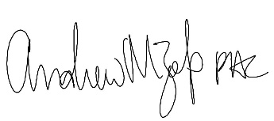
______________________
Program Director

