

Policy Name: Student Well-Being

ARC-PA Standard: A3.07

Policy Statement:

Physician Assistant students sometimes experience stress, complicated decisions or challenging personal situations which may impact their progress in the program. The Program recognizes that situations may arise which could lead to a student not being able to perform to the best of their ability. The following policy addresses the timely access and referral to services in these situations.

If a faculty member or staff recognize that a student is struggling with personal issues, a referral will be made to the University Counseling Center for free counseling with professional counselors who have extensive experience working with a diverse student population.

The counseling process can help students learn skills to cope with problems and develop new ways of thinking and learning. They offer individual and couples counseling to deal with the following issues:
- Relationship or family conflicts
- Stress and anxiety
- Grief or loss
- Social and peer pressure
- Sexual identity questions
- Trauma and post-traumatic stress
- Adjusting to college life
- Feeling down or depressed
- Body image or eating disorders

The Physician Assistant Program adheres to the university’s policy and procedures regarding referral of a student in distress found at http://wmich.edu/studentaffairs/concern . Policies and procedures identify when to make a referral, how to encourage students to seek assistance, and what happens after you submit the referral. Furthermore, the policy offers information on how to recognize students in distress, and how to share concerns with students. The appropriate referral form is available on the website, and must accompany all referrals.

Date Reviewed: 4/30/2026
To Be Reviewed 5/01/2027

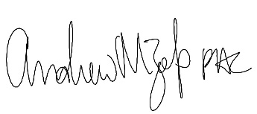
______________________
Program Director

