

Policy Name: Student Identification

ARC-PA Standard: A3.04

Policy Statement:

All students must be clearly identified as a PA student in the clinical setting to distinguish them from other health profession students and practitioners.

PA students are required to have the WMU PA logo on their white coat and WMU issued PA student badge. If a white coat is not required, students at a minimum are required to wear the WMU PA student badge at all times.

Date Reviewed: 4/30/2026
To Be Reviewed: 5/1/2027

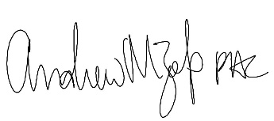
______________________
Program Director

