

Policy Name: Eligibility for Board Certification Exam

Policy Statement

The Physician Assistant (PA) Program is responsible for protecting the public’s welfare by ensuring that all students who complete the Program meet or exceed the established minimum performance levels. Accreditation standards dictate that PA programs are expected to assess whether each student has the knowledge, interpersonal skills, patient care skills and professionalism required to enter clinical practice (ARC-PA Standard C3.04). The PA program is required to verify eligibility of each student to sit for the Physician Assistant National Certification Exam (PANCE) administered by the National Commission on Certification of Physician Assistants (NCCPA). This policy outlines the eligibility requirements for verification.

Requirements for Eligibility for Board Certification Exam

- Graduation requirements completed:
  - Completion of 95 credit hours of required courses with a grade of C or higher
  - Cumulative GPA > 3.0

Upon completion of these requirements, the program director will verify with NCCPA the student’s eligibility to sit for the PANCE.

Date Reviewed: 4/30/2026
To Be Reviewed: 5/01/2027

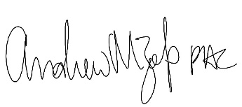
______________________
Program Director

