

Policy Name: Didactic Year Remediation Policy

ARC-PA Standard: A3.14

Policy Statement:

Each student in the Physician Assistant program must achieve a level of success as outlined in the grading policy. The Program recognizes that situations may arise which could lead to a student not being able to achieve a minimum level of competence. The following remediation policy addresses deficits in a given course, semester or year.

Test Remediation

When extenuating circumstances impact performance on a single exam within a course during the didactic year, remediation is left to the discretion of the instructor of record. If remediation is granted, the instructor/academic coordinator and the student will develop a written plan of remediation, including a time frame for completion of the work and a date for reassessment. The purpose of remediation is not to simply replace a low exam score, but rather allows a student to relearn the material and retake a single exam within a given course during one semester. Quizzes are considered formative and thus are not eligible for remediation.
- To be eligible to request test remediation during the didactic year, a student must score below 70% on the exam.
- If the score on the remediation exam is less than the original exam score, the remediation exam score will be entered into the grading matrix.
- The maximum score that can be achieved by the student from the remediation exam that will be entered into the grading matrix is 70% for didactic year exams. This should be considered when requesting remediation, as a score of 70% on a didactic year exam, for example, may not improve the overall course grade.
- If a student desires remediation for a failed exam, a written request, including a detailed explanation of the extenuating circumstances, must be received by the instructor of record within three business days after exam scores are available.
- Failure to complete the remediation plan as outlined may lead to failure of that exam and possible failure of the course. The Physician Assistant Program Director will be notified of any student failing to complete the remediation plan by the specified date.

Course Remediation

Should the Physician Assistant student fail any MDSC course, it will trigger an academic review. The course grade will not be changed because of this academic review, but the committee may recommend various courses of action including, but not limited to, deceleration and repeating the course with the next cohort, repeating the course independently with/without deceleration or dismissal from the program. See Semester and Academic Review Policy.

A second failure of any Medical Science (MDSC) course will result in immediate dismissal from the Physician Assistant Program.

If course remediation is agreed upon, a written remediation plan including a time frame for completion will be developed by the committee and approved by the program director. If course remediation results in deceleration, this would change the student’s graduation date.

A student may appeal against any grade or program dismissal by following the process outlined in the WMU Graduate Catalog. See the attached document “Grade and Program Dismissal Appeals” for details.

High Risk Student Identification

During the didactic year of training, faculty will identify students who are at high risk of having academic or clinical struggles during their clinical year or who may struggle to pass PANCE on the first attempt. This will be determined by review of their comprehensive end of module exam scores and/or end of MDSC course grade. Any student who has a C or lower in any MDSC course will be notified to meet with the assigned adviser and academic coordinator to discuss strengths or weaknesses in that specific course. That meeting along with its date will be documented in the student’s permanent file.

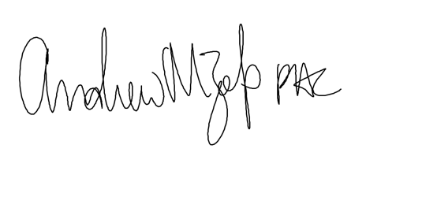
Date Revised: 4/02/2024
Date Reviewed: 4/30/2026
Be Reviewed: 5/01/2027
__________________________________________________________________________
Program Director

