

Policy Name: Completion Requirements

ARC-PA Standard: A3.14b

Policy Statement:
- Standard Program Duration
The PA Program is designed to be completed in 24 months of full-time study. Extensions beyond this timeline are not guaranteed and are subject to review.
- Maximum Completion Timeframe
  - Graduate students at Western Michigan University have no more than six-years from date of matriculation to complete their master’s degree.
- Leave of Absence and Interruption of Training
  - Students requesting a leave of absence must follow the PA Leave of Absence Policy
  - Approved leaves or other academic interruptions count toward the six-year maximum.
- Academic Progression
  - Students must meet all academic and professional conduct standards as outlined in the PA Student policies to progress through the curriculum.
  - Delays due to academic deficiencies may warrant individualized remediation plans, but all coursework and clinical rotations must still fall within the six-year time frame.

Date Reviewed: 4/30/2026
Be Reviewed: 5/01/2027
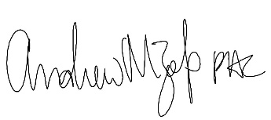
______________________
Program Director

