

Policy Name: Faculty as Student Health Care Providers

ARC-PA Standard: A3.06

Policy Statement:

Faculty, Program Director and/or Medical Director cannot provide any type of health care to students in the program, except in the case of an emergency.

In several courses during the didactic year, we will focus on the process of learning diagnostic skills. These physical exam techniques and diagnostic tests are for educational purpose only, NOT medical treatment. No health care provider-patient relationship is established during the educational diagnostic process, and no medical advice will be given as a result of the process. Students are responsible for their own health. It is the student’s responsibility to monitor their own health and seek medical treatment when needed.

Date Approved: 4/30/2026
Be Reviewed: 5/1/2027

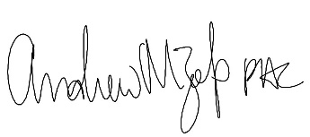
______________________
Program Director

