APPLICANT’S GUIDE FOR SABBATICAL LEAVE APPLICATION USING INFOREADY

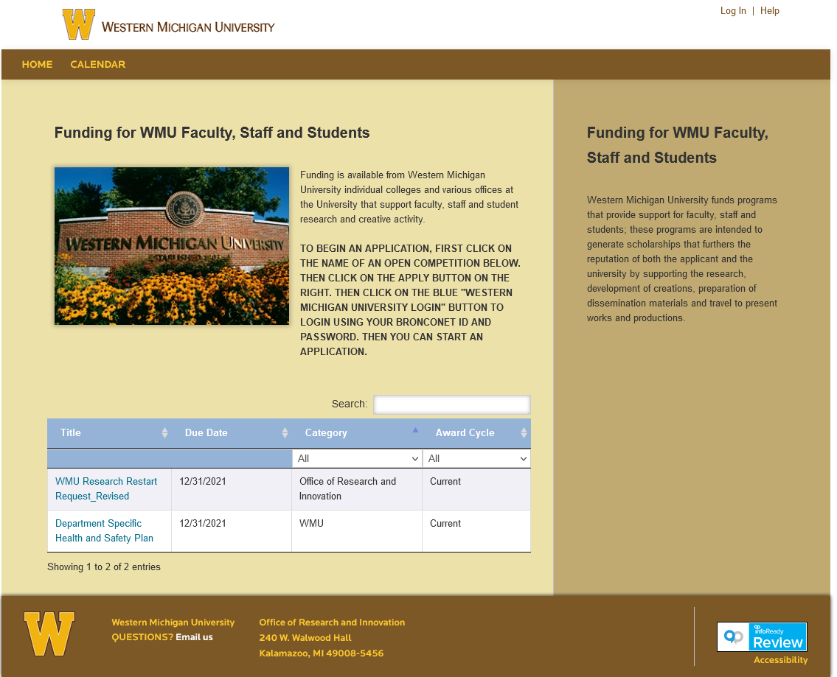
- Go to https://wmich.infoready4.com/ to log in. Click on Log In in the upper right hand corner of the screen.
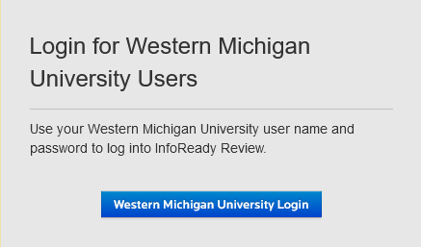
- Use the “Login for Western Michigan University Users” box to login. Click on the blue Western Michigan University Login box. This will take you to the WMU Login page.

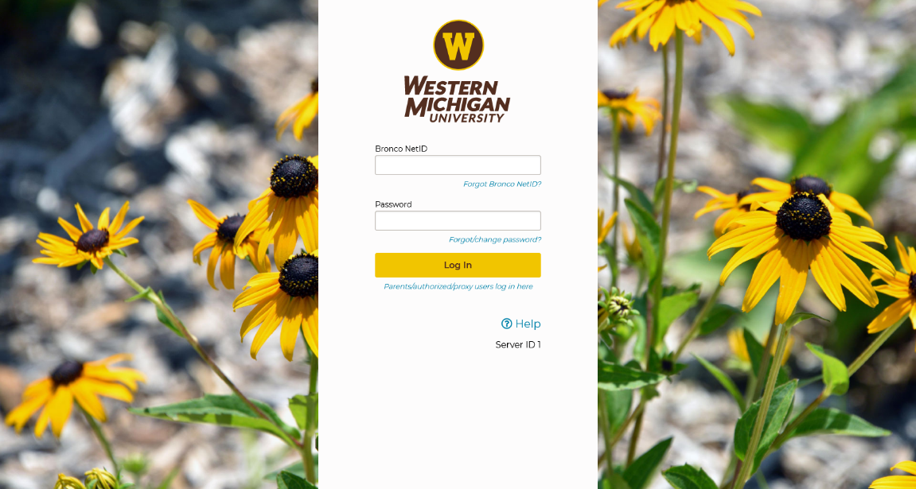
- Enter your Bronco NetID and Password and click the yellow Log In button.

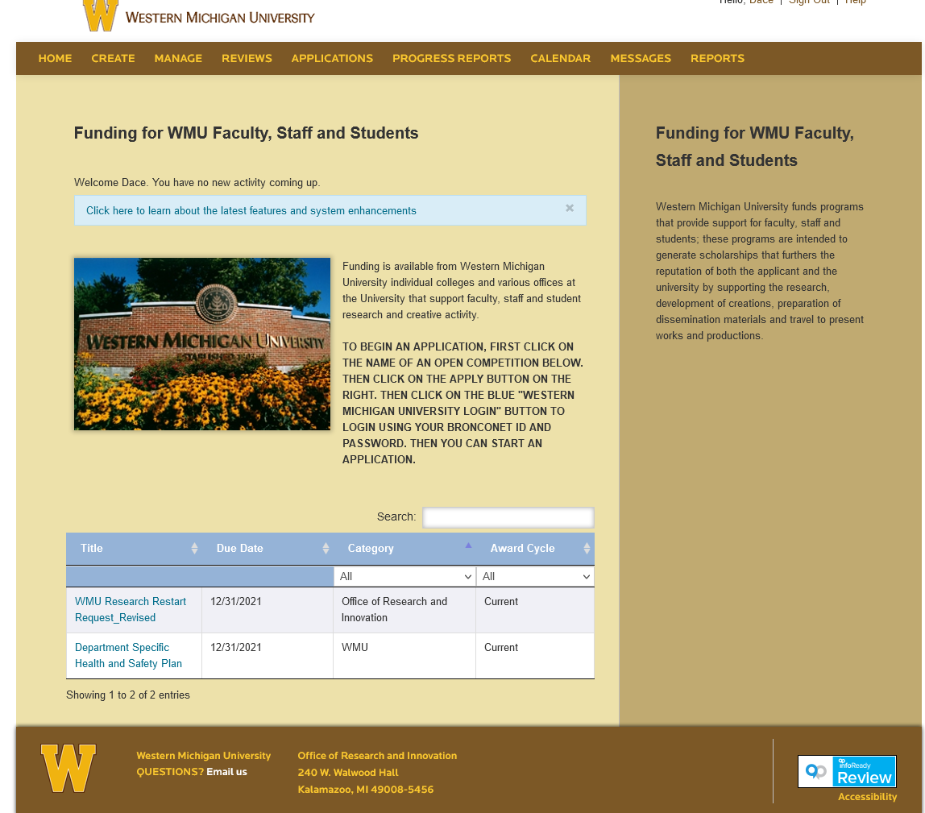
- You are now at the InfoReady Home page. Find “Application for Sabbatical Leave 2022-23” in the list provided at the bottom of the page and click on the title.
- You are now ready to work on your 2022-23 sabbatical leave application. Please note that there are two buttons at the bottom of the page—Save as Draft and Submit Application. You may click on the Save as Draft button to save your work and then return to it later. When your application is complete, click on the Submit Application button.

- Deadlines:
  - Applications must be submitted by October 1.
  - Department/School Sabbatical Leave Committee and the Chair/Director must complete their reviews by November 1.
  - Deans must complete their reviews by November 15.
  - The University Sabbatical Leave Committee must submit their review by December 15.
  - The Provost must submit her review by January 31.
Questions: contact Lisah Crall: lisah.crall@wmich.edu or Erica Martinez: erica.martinez@wmich.edu

