Additional Resources Scheduling
This is used when you are scheduling an appointment with someone outside your Success Team.
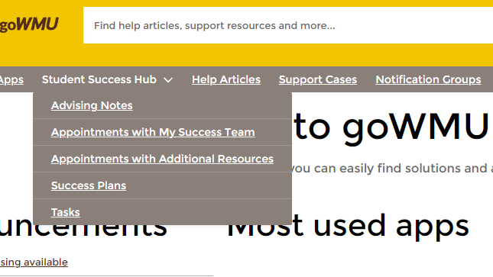
Log in to GoWMU. Select Student Success Hub from the navigation bar, and then choose Appointments with Additional Resources. These are staff that are not yet on your Success Team but that you need a meeting with.
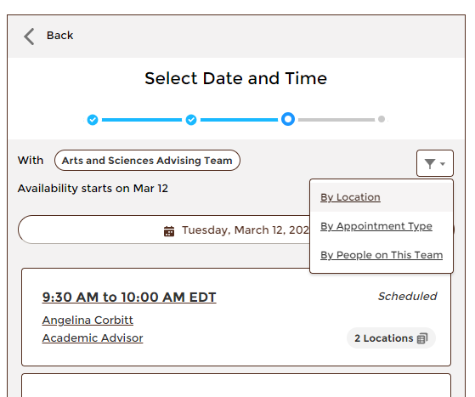
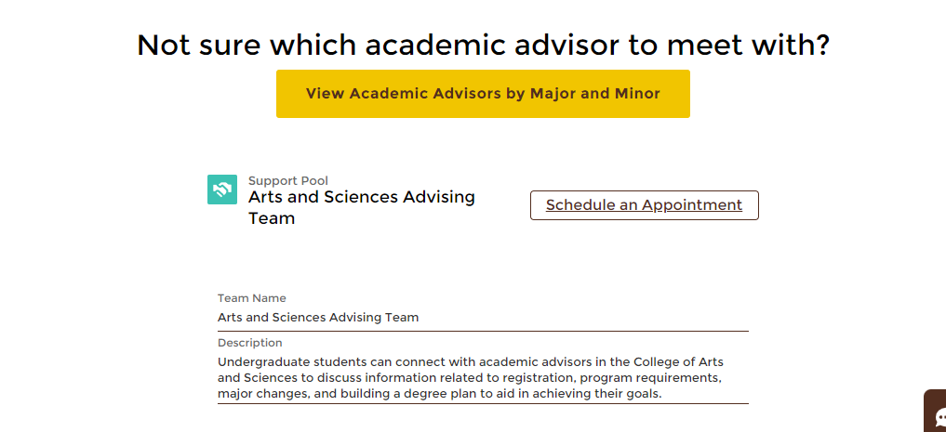
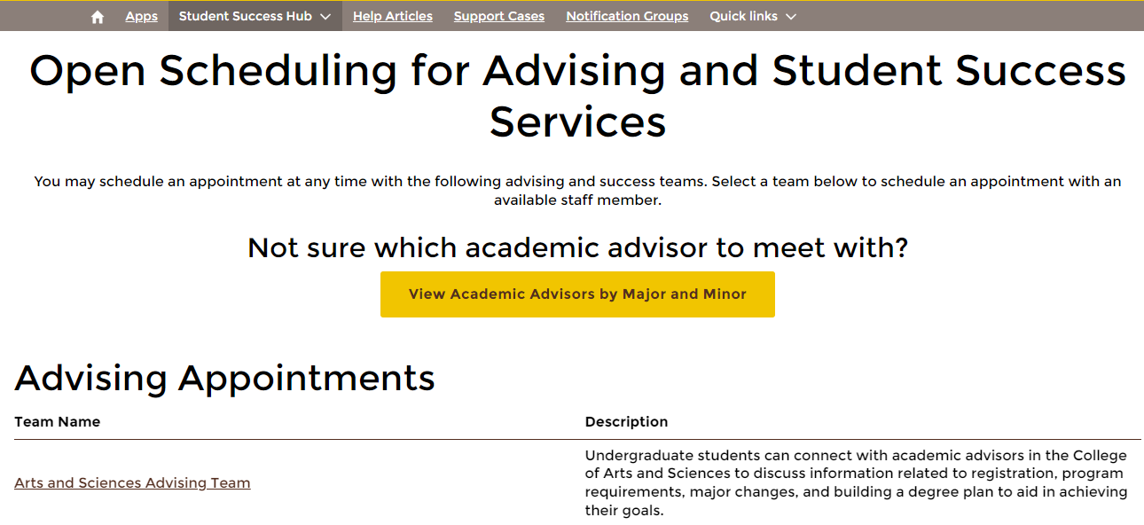
Click the filter button and select “By People on This Team” and find the advisor you need. Then choose a date and location. You’re done!
Click schedule an appointment, and then choose your appointment topic.
Select the Arts and Sciences Advising Team (unless you need to schedule with someone outside of Arts and Sciences. Then select their Team).

