

Policy Name: Acquiring Rotation Sites

ARC-PA Standard: A3.08

Policy Statement:

Policy Statement: Students are not required or permitted to provide or solicit clinical sites or preceptors. If you are aware of a possible clinical site or preceptor, please provide contact information to the Coordinator of Clinical Rotations or Director of Clinical Education.

Date Approved: 4/30/2026
To Be Reviewed: 5/1/2027

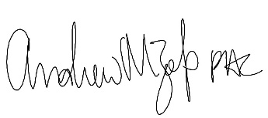
______________________
Program Director

