Tips for A Successful WMU Essential Studies Course Proposal
Jonathan Bush, WMU Essential Studies Faculty Director
Jonathan.bush@wmich.edu | February 22, 2026

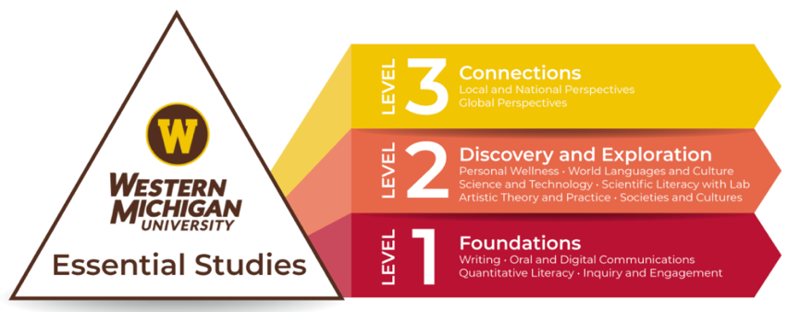
Strong proposals clearly align SLOs, demonstrate assessment quality, show departmental support, and arrive at CRAC polished and complete. All proposals should successfully address/answer three core questions:
- Does the course maintain the integrity of the stated SLOs?
- Is the course in the right category and level?
- Does the course have an appropriate and well-articulated assessment plan?

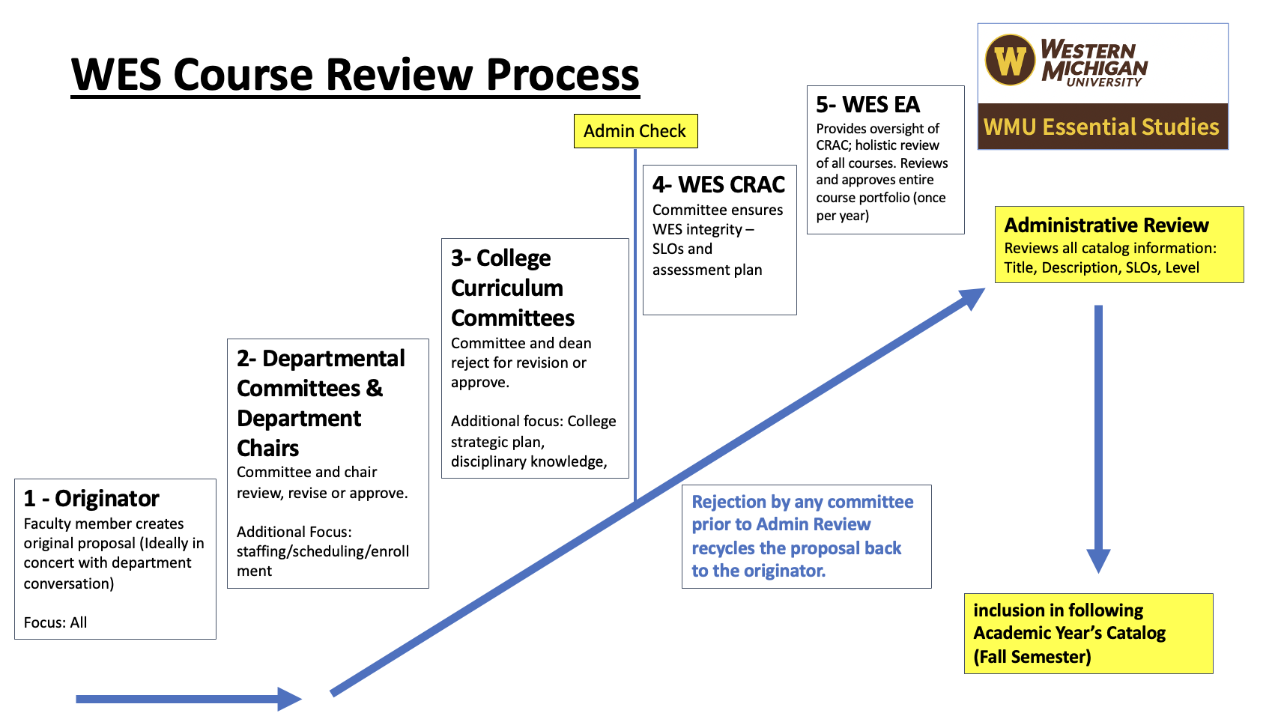

Proposal Must-Dos

1. Begin with a focus on maintaining the Integrity of the selected WES SLOs
- Review and understand the SLO Outcome Rubric for each SLO (https://wmich.edu/facultysenate/wmuessentialstudies/wesrubrics).
- Ensure selected SLOs match course content and assignments.
- Place the course in the correct category and level.
- Provide clear alignment between assessments and SLOs.

2. Provide a Viable Assessment Plan
- Balance SLO assessment with instructor flexibility.
- Broad assessments are appropriate and include specific language
- Read the instructions and utilize only the WES Assessment Plan template for the category/level for the proposed course. Delete the rest. (https://wmich.edu/essentialstudies/facultyresources)

3. Coordinate Early with Department Committees and Leadership
- Consult department chair and curriculum committees.
- Address scheduling, staffing, resource needs.
- Confirm course fit with departmental priorities.

4. Demonstrate Department and College Support
- Show that the course aligns with strategic plans.
- Identify how it complements existing programs.

5. Submit a Polished Proposal
- Provide a fully developed syllabus.
- Complete all Curriculog fields clearly and accurately.
- Ensure catalog descriptions are concise and accurate.
- Include All Required Materials (Syllabus, rationale/answers, assessment plan, rubrics, catalog language).

6. Address Potential Issues Early
- Identify and resolve potential conflicts before CRAC review.
- Ensure all issues of staffing, conflicts, or assessment are resolved.

Proposals Must-Avoids

1. Submitting Without Departmental College Consultation
- Surprising your chair or committee with a new course.
- Creating conflicts with existing curriculum (in and across departments and colleges)

2. Choosing Poorly Matched or Poorly Articulated SLOs or Misjudging the Category/Level
- Selecting SLOs and categories/level that the course does not effectively address or assess.
- Misunderstanding SLO traits as defined in SLO Outcome Rubrics (https://wmich.edu/facultysenate/wmuessentialstudies/wesrubrics).

3. Submitting an Incomplete Proposal
- Missing documents or placeholders will delay approval.

4. Expecting CRAC to Fix Department/College Issues
- CRAC does not evaluate staffing, capacity, or curricular conflicts between programs, departments, or colleges.
- Missing committee timelines may delay catalog inclusion.

Best Courses

- Should be available to as many students as possible.
- Contain assessments that are specific to the SLOs but also broad enough to be administered with fidelity.

