Section 4.1: Roles and Responsibilities
Field experience is the signature pedagogy of the profession because it is the most fundamental way that social work practice is taught. A successful field placement consists of and involves coordination among three key groups: The Student, the Site Supervisor, and the Faculty Field Liaison.

Student Intern  (BSW or MSW) | Field Supervisor (Primary or Secondary) | Faculty Field Liaison  (Course Instructor)
Role Overview:  Engages in supervised Field Education.  Applies coursework instruction to experiential learning/ practice.  Developing core professional competencies and professional identity under supervision. | Role Overview:  Hold required credentials and practice experience necessary for designing internship learning opportunities for students.  Demonstrate an understanding of CSWE competencies. | Role Overview:  Serves as the academic point of contact between the university, the student, and the field placement site.  Ensure academic integrity and support for the learning process.  The FFL also serves as a course instructor for a section of either Field Education I (Fall) or II (Spring) / Concentration or Specialization.
Responsibilities:  Complete agency orientation and follow all organizational policies. Collaborate with Field Supervisor to develop a learning contract aligned to CSWE competencies. Maintain regular attendance and uphold professional behavior.  Engage in direct and indirect practice, as appropriate to their concentration.  Participate in supervision and seek feedback.  Complete all required documentation and assignments for the field course.  Uphold the NASW Code of Ethics in all interactions and decisions. | Responsibilities:  Oversee and guide students’ field placement experiences. Provide structured supervision and feedback through support and guidance.  Ensure student practice experiences and activities align with CSWE Competencies, agency policies, laws, and ethical standards. | Responsibilities:  Conduct midterm and final evaluations.  Conducts agency visits with students and field supervisors. Monitor student performance and assess alignment with learning objectives.  Support conflict resolution and guide students through challenges in the field.  Provide feedback on student assignments related to field education.  Ensure integration of theory and practice through ongoing dialogue with students

Western Michigan University School of Social Work Field Manual,2025-26

Section 4.2: Field Education Department

Field Coordinator
Field Facilitator/ Navigator (PT Employee)
Field Navigator Graduate Assistant
Role Overview:
The Field Coordinator plays a vital role in preparing, screening, and supporting social work students throughout the field placement process.
Role Overview:
Ensure that all pre-placement requirements are completed and supports the matching process of student across programs paying specific attention to student identified professional goals and area of study.
Role Overview:
Supports and Coordinates the School of Social Work Buddy Program.
Responsibilities:
Ensures students are vetted for field readiness and have completed all components of the field application and orientation processes.
Screen students for personal values and professional interest, and support the field placement matching process. Match students with appropriate field placements based on interests and learning needs.
Maintain relationships with field agencies and ensure compliance with partnership standards.
Supports the coordination of field orientation, training, and student preparation.
Support the development of new field sites and community partnerships.
Monitor student progress and address placement disruptions or concerns.
Ensure that policies align with CSWE accreditation standards and university guidelines.
Responsibilities:
Ensures the monitoring of the field placement process on both the student and the agency (Student Agreement, Agency Agreement, Liability Insurance Monitor completion of field forms, evaluations, and competency benchmarks.
Ensure compliance with university, CSWE, and agency requirements.
Collaborate with field instructors, faculty, field directors and students to address challenges.
Assist students with time management, self-advocacy, and navigating complex systems.
Responsibilities:
Supports and Coordinates the School of Social Work Buddy Program.
Match incoming students with experienced “buddy” mentors based on program track, concentration, and/or shared interests.
Maintain and update a roster of active buddy pairs
Provide buddies with clear guidelines, expectations, and resources for peer support.
Organize an initial meet-and-greet or orientation session for matched pairs
Act as a primary contact for buddies to address questions, concerns, or challenges.
Conduct periodic check-ins with both mentors and mentees to ensure engagement and support. Send regular communications with tips, resources, and conversation prompts to encourage interaction.
Collect feedback from participants on the buddy experience.
Prepare summary reports for the Field Education Department to inform program improvement.

Western Michigan University School of Social Work Field Manual,2025-26

Field Education Directors

Role Overview:
- The Field Education Directors provide overall leadership, strategic direction, and administrative oversight for WMU’s Field Education Program.
- Playing a pivotal role in ensuring that all field placements meet accreditation standards, offering high-quality learning experiences, and preparing students for professional social work practice.

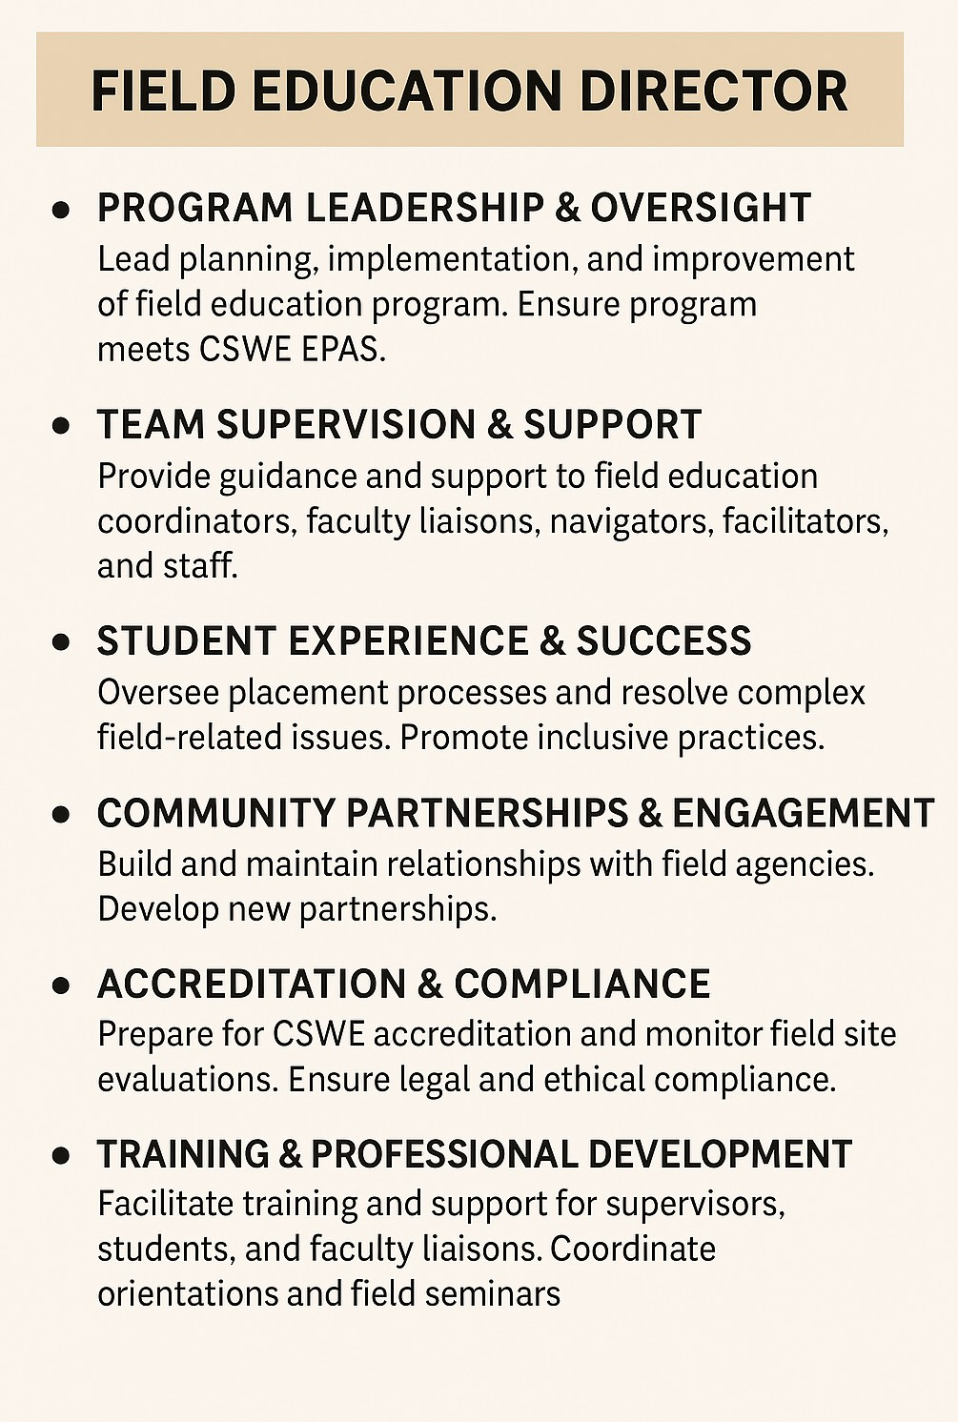
Field Education Director vs. Associate Director – Responsibilities
Supports the daily operations of the field education program.

Ensures compliance with CSWE EPAS accreditation standards.

Direct the MSW Field program and oversee the placement process

Maintains and updates policies, procedures, and the field education manual.

Maintains communication with agency field supervisors.

Serves as a point of contact for MSW Foundation and Concentration FFL

Address placement issues with faculty liaisons and support conflict resolution.

Helps recruit and onboard new field sites.

Co-develops and facilitates orientation and training for students, supervisors, and faculty liaisons.

Monitors completion of forms, evaluations, and competency benchmarks.

Oversee placement matching processes and resolve placement issues.

Assists with CSWE and university compliance reporting.

Supports the development of innovative field education models and policy updates.
Ensures compliance with CSWE EPAS accreditation standards.

Directs the BSW Field program and oversees the placement process

Oversee the Affiliation Agreement process between WMU’s SSW and External practice sites.

Maintains communication with agency field supervisors.

Leads quarterly Field Education Meetings with Faculty Field Liaisons

Helps recruit and onboard new field sites.

Supervises field education staff,

Co-develops and facilitates orientation and training for students, supervisors, and faculty liaisons.

Monitors completion of forms, evaluations, and competency benchmarks.

Oversee placement matching processes and resolve placement issues.

Prepares CSWE accreditation reports and supports site visits.

Manages the field education budget and allocates resources.

Field Education Director | Associate Field Education Director
Leads and oversees the entire field education program.




Western Michigan University School of Social Work Field Manual,2025-26

