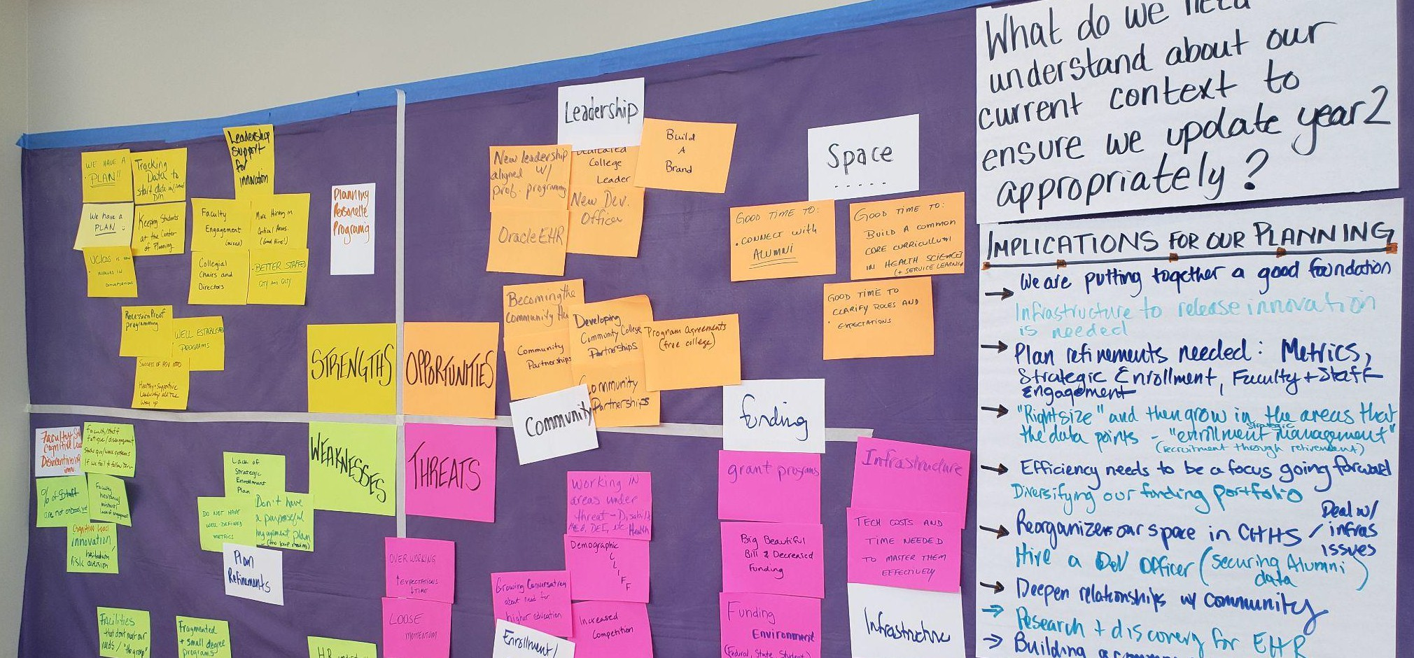

Table of Contents
Event Agenda 2
Participant Expectations 2
Reference Materials 3
Updated Documentation for Sept 2025 with Strategic Directions and Implementation Timelines 3
Strategic Directions Team Reports 3
Environmental Scan Using S.W.O.T 5
Implications for our Planning 6
Dean’s Update 6
Curriculum Adaptation Discussion 7
Engaging Faculty 8
Year Two Implementation Timeline 9
Coordination 11

Event Agenda

 | Tues | Wed | Thurs
Morning | 9am Opening, Check-in |  | 9am Open
 | Refresh Strategic Plan Product  In SD Teams - Annual Review / Reports |  | Cross-Walk Timeline to Updated Envision Templates
 | Crowd-source key questions to get input from the Leadership Team on |  | Cross-Tag CHHS SD to University Strategic Plan
Lunch | 11:30 - 1:00 Lunch |  | 12 - 1pm Lunch
Afternoon | SWOT Env Scan  Dean’s Report - Changes to Financial Aid & Implications  Discussion: Guidance on how to adapt our degree programs to new financial aid reality & IPE crosswalk simultaneously | Provocative Proposals: Timeline deliverables  Strategic Directions Teams  - Propose Updated Deliverables for 2026  Review and Prioritize | Celebration of the Team & the Year’s Accomplishments  2pm Close
 | Brainstorm: How to get faculty engaged in the adaptation process? | Build Implementation Timeline

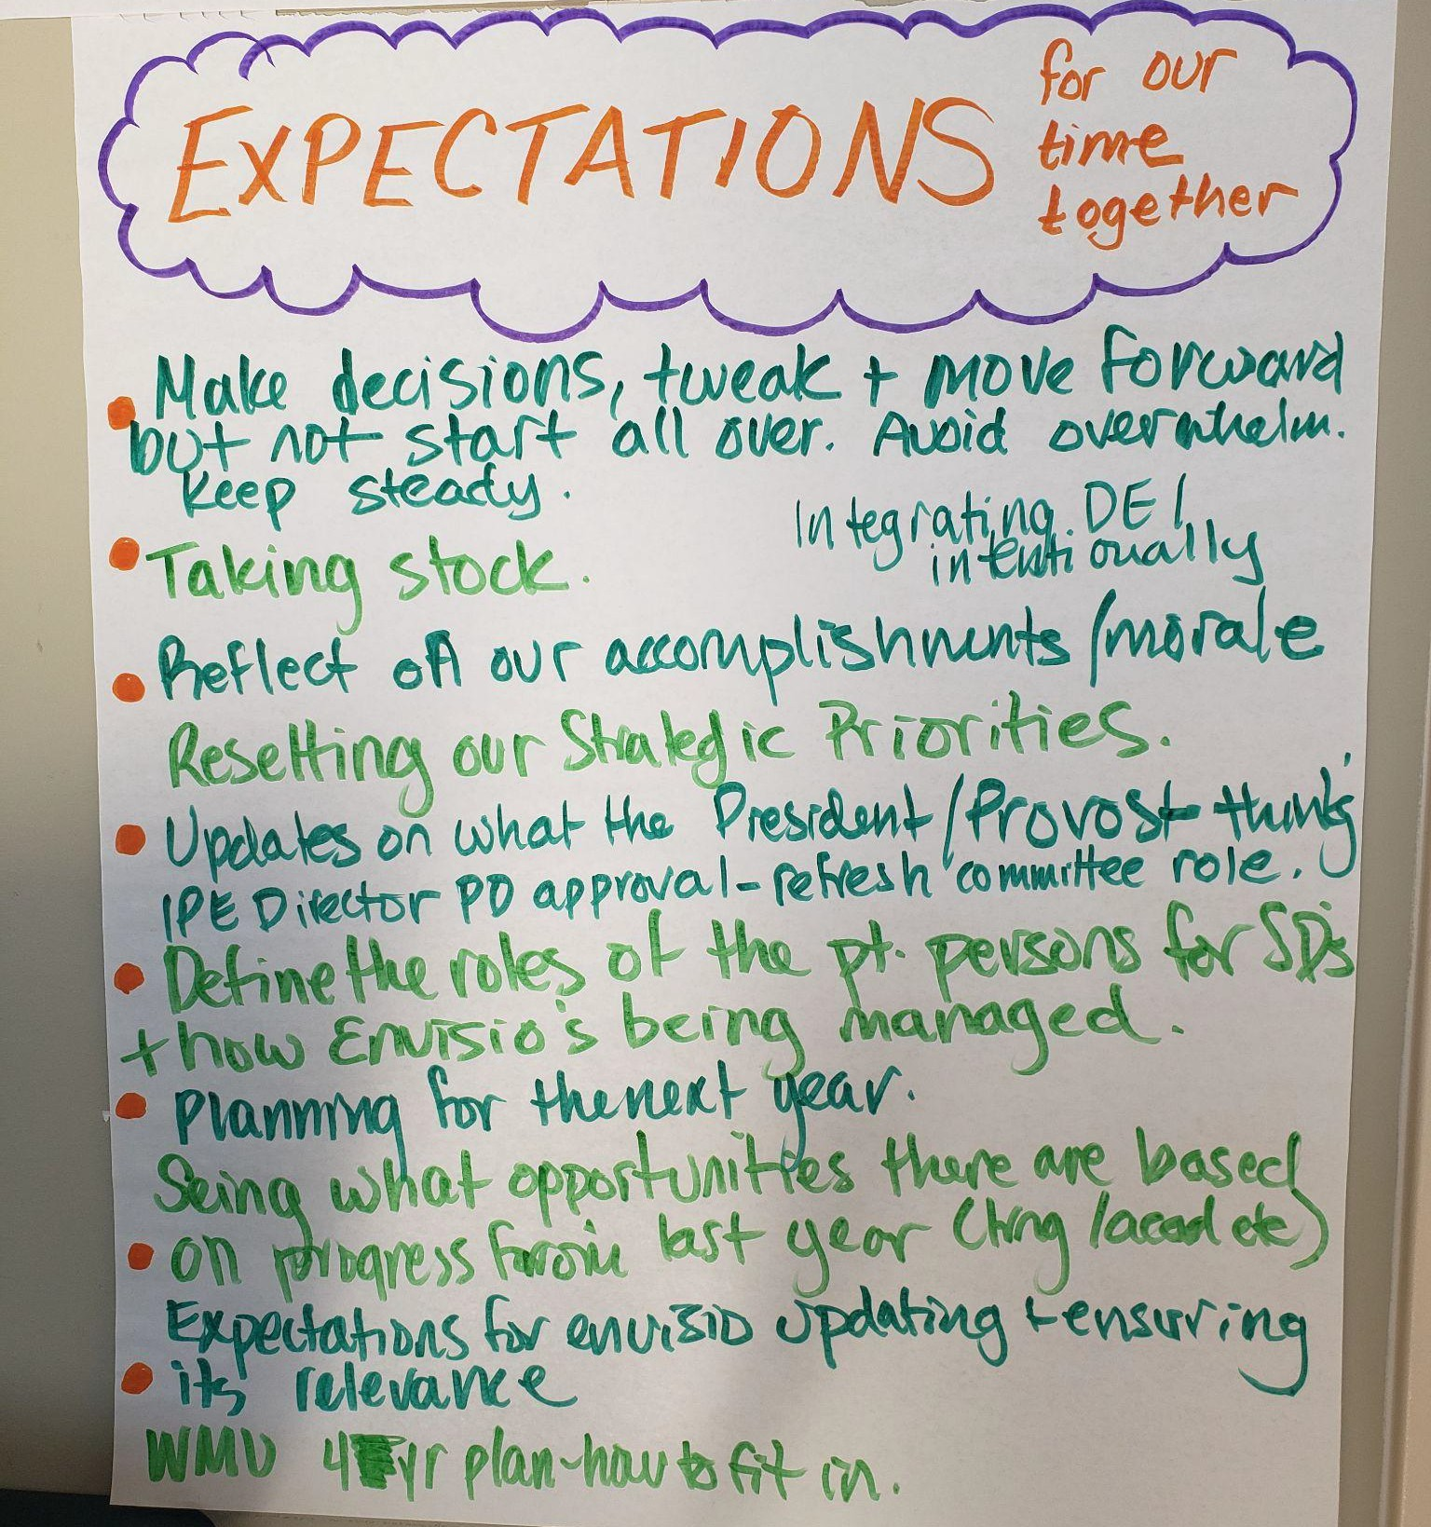
Participant Expectations
- Make decisions, tweak and move forward but not start all over. Avoid overwhelm. Keep steady.
- Taking stock.
- Reflect on our accomplishments / morale.
- Resetting our strategic priorities
- Updates on what the President / Provost thinking
- IPE Director PD approval - refresh the IPE committee role
- Define the roles of the Point persons for the SD’s & how Envisio is being managed
- Planning for the next year
- Seeing what opportunities there are based on progress from the last year (training, acad, etc)
- Expectations for Envisio updating & ensuring it’s relevance
- WMU 4year plan - how to fit in.

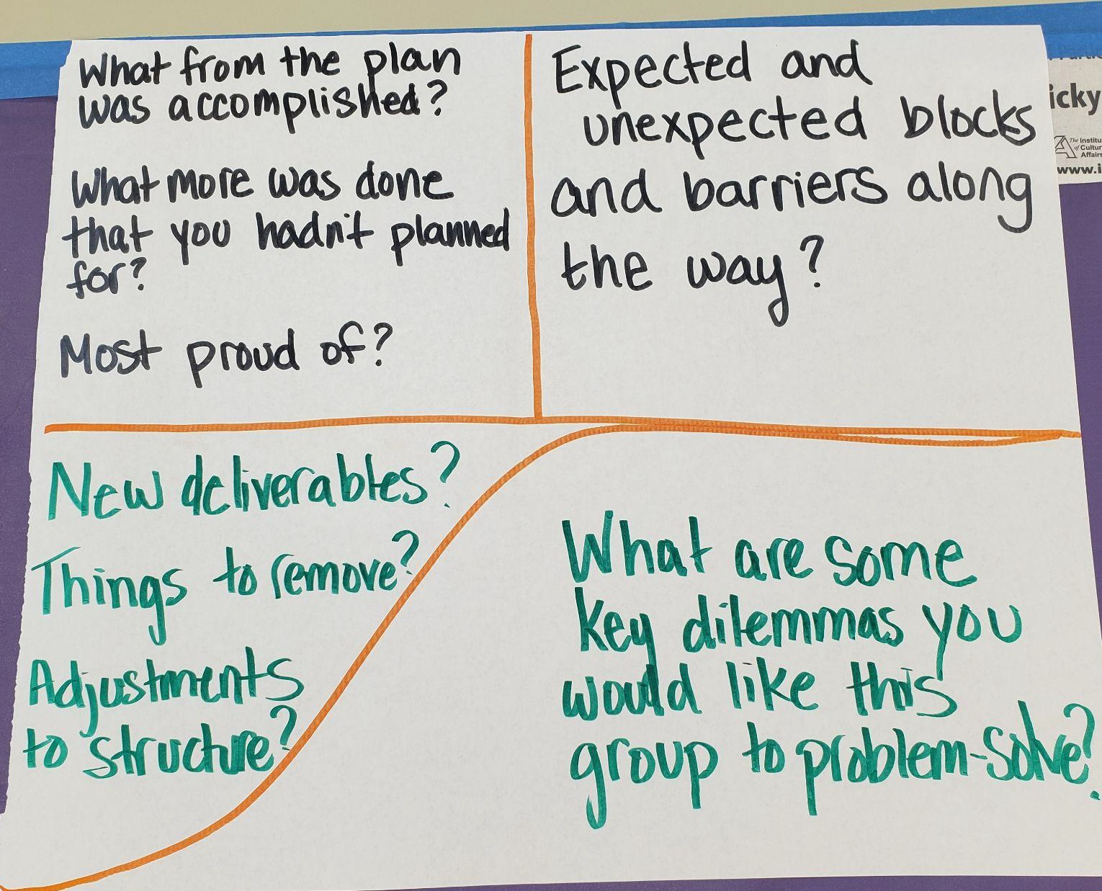
Reference Materials
August 2024 Strategic Planning Event Documentation
WMU CHHS Leadership Retreat Documentation v2.docx
Updated Documentation for Sept 2025 with Strategic Directions and Implementation Timelines

Strategic Directions Team Reports

Strategic Direction:
[Re]Igniting College Pride and Belonging
Team Members:
Accomplishments:  - Belonging survey, college wide and communications survey  - Collected info from depts-snapshot of communication  - Events: Chili Cookoff, potluck, faculty/staff awards, 8 lunch and learns, movie nights  - Marketing Plan  - Capital, Homecoming tailgate and sponsoring 5K  - CHHS shirts  - Book Club  - Major growth in social media engagement–need to expand to tiktok, student “challenges” | Challenges:  - Committee availability–lack of participation in college  - Empty building  - Lost Betty and Trevor  - Growth of online programs  - Housing and food was a disaster this wummer–no “college pride” during 6 week summer programs
Recommendations for Year 2:  - Coordinate day of service with RSOs and community partners  - Re-establish lunch and learn for students/faculty/staff  - Graduate Lounge  - Graduate students should be working in person–no remote work–this helps with empty building  - Bring students into committee to shape how to engage them  - Rotate lunch and learn across departments? Determine overall purpose to determine ROI | Key Questions to Address Together:  Who (students/student groups) can we add to our committee to complete our work–MRO?

Strategic Direction: Modernizing our Systems and Procedures
Team Members:
Accomplishments:  - EXXAT  - Completed System Survey  - HR Process Drafts  - Employee Handbook Draft | Challenges:  - University Systems  - Timelines (short / long)  - EXXAT - cost per student apprehension
Recommendations for Year 2:  - Finalizing HR onboarding / training  - Classroom scheduling  - Handbook implementation  - All systems go! | Key Questions to Address Together:  Should we split into two teams (University / College Systems)  University - Advocacy and Influence College - Current systems change efforts  Address the challenge of timelines of systems change with just one group taking them on.  Answer - group trusts the judgement of the team to decide this.

Strategic Direction: Collaborating Internally and Externally
Team Members:
Accomplishments:  - Curriculum mapped to IPEC  - Identified IPE experts  - IPE director: recommended job description  - IPE CHHS committee & CIEW attended virtual IPEC conference  - Outside employment form: added survey R/T community boards  - IAI | Challenges:  - Role configuration (who has the ball) - own the process  - Schedules - how to collaborate with all the different course schedules
Recommendations for Year 2:  - Hire IPE Director  - Establish CHHS IPE committee roles / objectives  - Website  - Needs assessment  - External partner database | Key Questions to Address Together:

Environmental Scan Using S.W.O.T.

What do we need to understand about our current context to ensure we update year 2 appropriately?
STRENGTHS | OPPORTUNITIES
Planning  - We have a plan 🙂  - We have a plan !!  - Tracking data to start data informed decision making  - Keeping students at the center of planning  - UC/CDS is now involved in conversations  Personelle  - Leadership support for innovation  - Faculty engagement (mixed)  - Collegial chairs and directors  - More hiring in critical areas (good hires!)  - Better staffed (Qty and Qlty)  Programming  - Recession proof programming  - Well established programs  - Success of HSV 1000 - Healthy & Supportive Leadership all the way up | Leadership  - New leadership aligned with professional programming  - Dedicated college leader  - New Development officer  - Build a Brand  - Oracle EHR  Community  - Becoming the Community Hub  - Community Partnerships  - Developing Community College Partnerships  - Community Partnerships  - Program agreements (free college)  Space  - Good time to: connect with Alumni  - Good time to: Build a common core curriculum in Health Sciences (& Service Learning)  - Good time to: Clarify roles & expectations
WEAKNESSES | THREATS
Faculty / Staff Cognitive Load Disincentivizing Innovation  - Faculty / staff fatigue / disengagement - status quo  /walk systems if we fail to follow through  - % of staff are not onboard yet  - Faculty hesitancy / mistrust / lack of engagement  - Innovation / hesitation / risk aversion / cognitive load  Plan Refinements  - Lack of Strategic Enrollment Plan  - Do not have well-defined metrics  - Don’t have a purposeful engagement plan (though we agree to keep moving with or without full engagement)  Facilities that don’t meet our needs / facilities group Fragmented & small degree programs  HR understanding of Needs | Enrollment / Competition  - Growing conversation about need for higher education  - Working in areas under threat - disability - H. Ed., DEI, etc  - Demographic Clllliiiiffffff  - Increased competition  - Community college is now free  - Not responding proactively & timely to needed change - enrollment  Funding  - Grant programs  - Big Beautiful Bill & Decreased funding  - Funding environment (federal, State, Student  - Cost of education increasing  Infrastructure  - Infrastructure  - Tech costs and time needed to master them effectively  Endurance / Resilience / Fatigue  - Overworking - increased expectations but less time  - Lose momentum

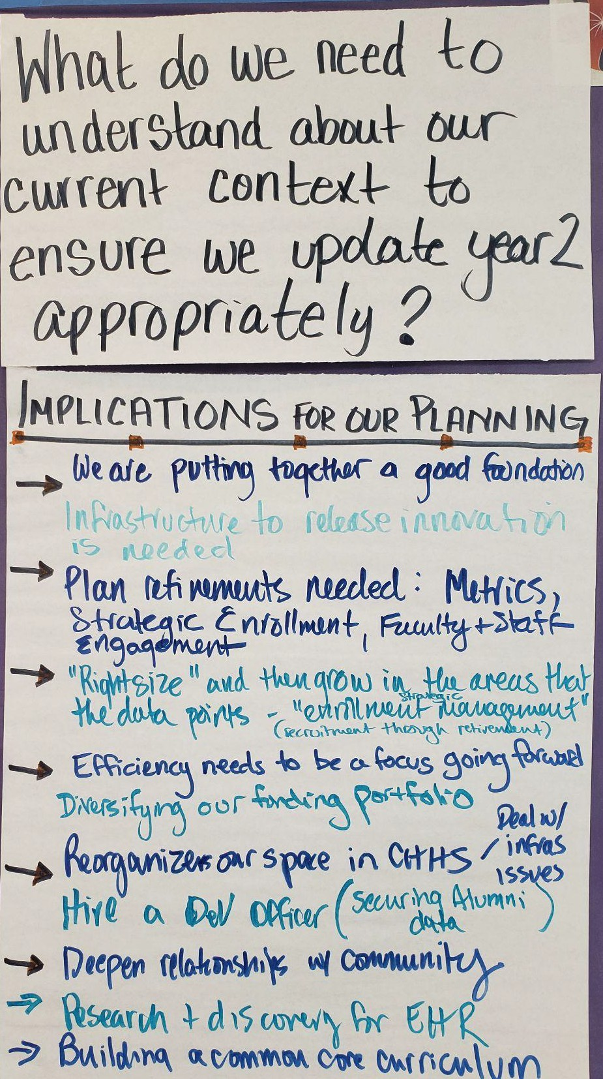
Implications for our Planning
- We are putting together a good foundation
- Infrastructure to release innovation is needed
- Plan refinements needed: Metrics, Strategic Enrollment, Faculty & Staff Engagement
- “Rightsize” and then grow in the areas that the data points - “strategic enrollment management"
- Efficiency needs to be a focus going forward
- Diversifying our funding portfolio
- Reorganize our space in CHHS - deal with infrastructure issues
- Hire a Development officer (securing the Alumni Data)
- Deepen relationships with community
- Research & discovery for EHIR
- Building a common core curriculum
- Deans advisory board / program advisory boards - is there overlap can they occasionally meet together?
- Unified Clinics - A clear statement on behalf of CHHS as to how it benefits our purpose and our cost share.

Dean’s Update

Strategic Direction: Dean’s Office
Team Members: Lillian, Jasmine, Alex, Joshua, Christopher
Accomplishments:  - Envisio & analytics dashboard  - SEC reorganized + project manager  - Pathway U in place  - Community Event help and did another  - Hired Christopher and have a plan More:  Started on workload DAB, New partnerships THRIVES, Wrote grant  UC Business and personnel plans Research Foundation  ADAA and other DO hires | Challenges:  - HR, not being fully staffed  - Leave policy (use it or lose it)  - Uncertainty with UC, EWB, partnerships, UC  - Lack of data  - Resistance to change  - Lack of focused strategies to bring faculty/staff on board
Recommendations for Year 2:  - Building  - Community Hub  - Finalize workload and implementation plan  - Refine Envisio and tie to WMU plan  - Clarify and document procedures–research, committees, etc | Key Questions to Address Together:  - Faculty and staff involvement  - Integrating IPE and curriculum  - Adjustment to new financial aid model  - Implement workload distribution  - Determining metrics and baselines

- Determine appropriate budgets for units and develop methods and metrics for financial distribution  - Refine/define CHHS metrics for CHHS Strategic plan  - Plan for financial aid | - Integrating THRIVES across strategic directions  - Building

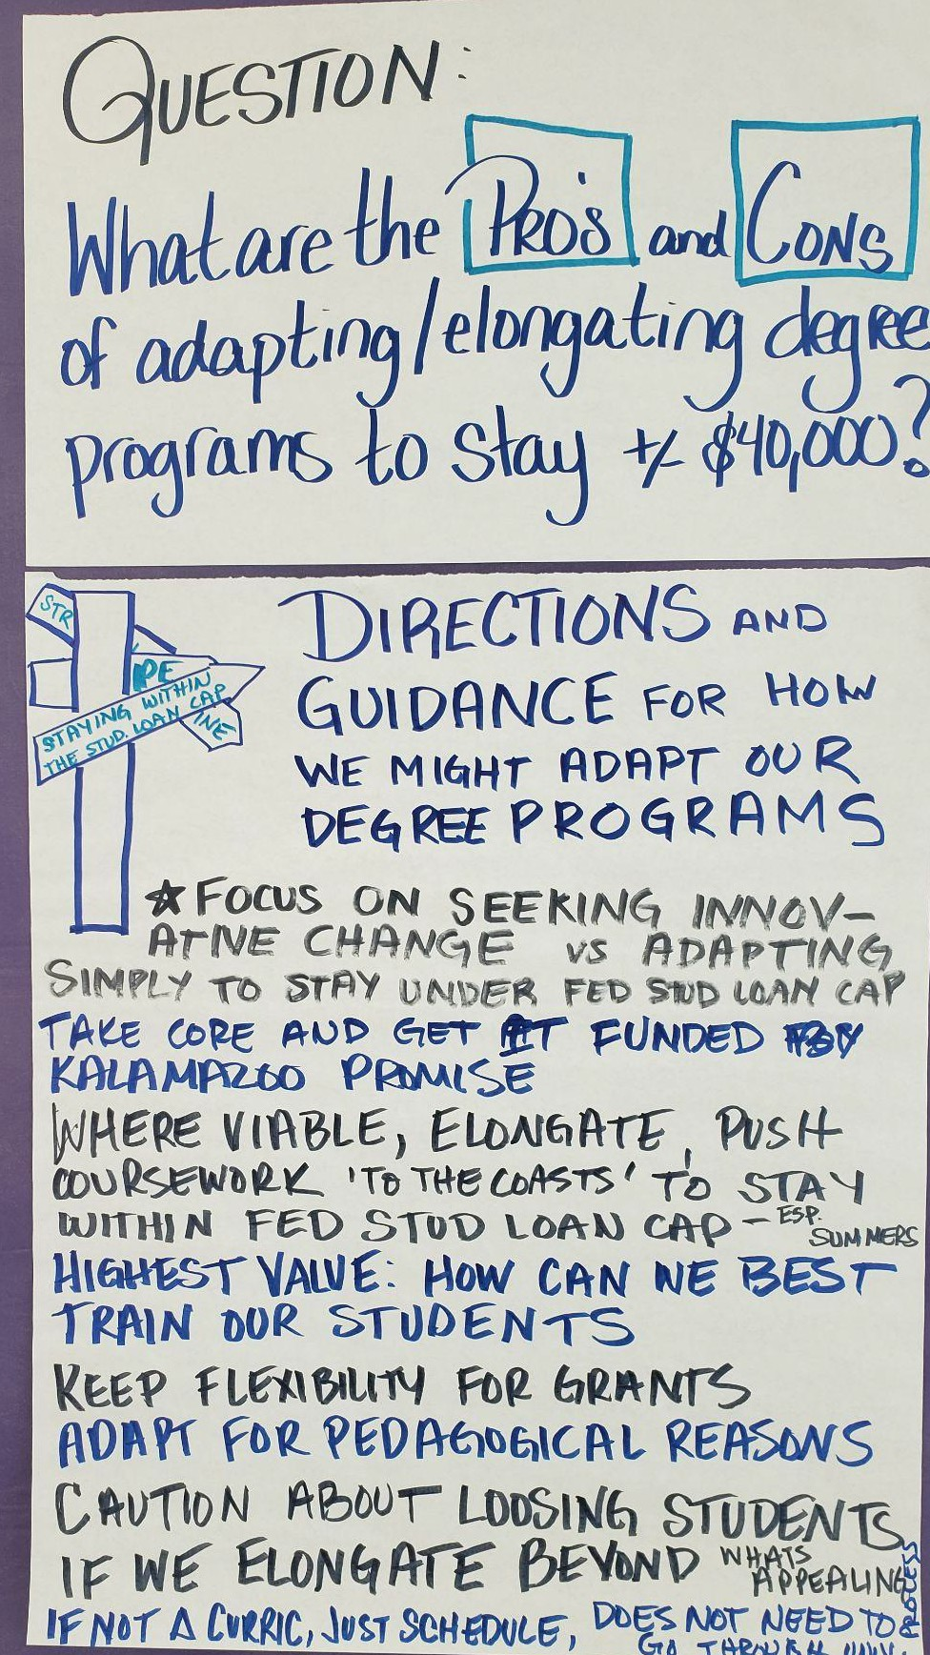
Curriculum Adaptation Discussion
What are the Pros and Cons of adapting / elongating degree programs to stay +/-
$40,000?

Directions and Guidance for How We Might Adapt our Degree Programs
- Focus on seeking innovative change vs adapting simply to stay under the federal student loan cap
- Take core and get it funded by Kalamazoo Promise
- Where viable, elongate, push coursework ‘to the coasts’ to stay with the federal student loan cap. Consider staying within summers.
- Highest value: How can we best train our students
- Keep flexibility for grants
- Adapt for pedagogical reasons
- Caution about losing students if we elongate beyond what’s an appealing timeline to graduation.
- If not a change in curriculum, if we are just rescheduling current credit hours, it does not have to go through the burdensome University approval process.

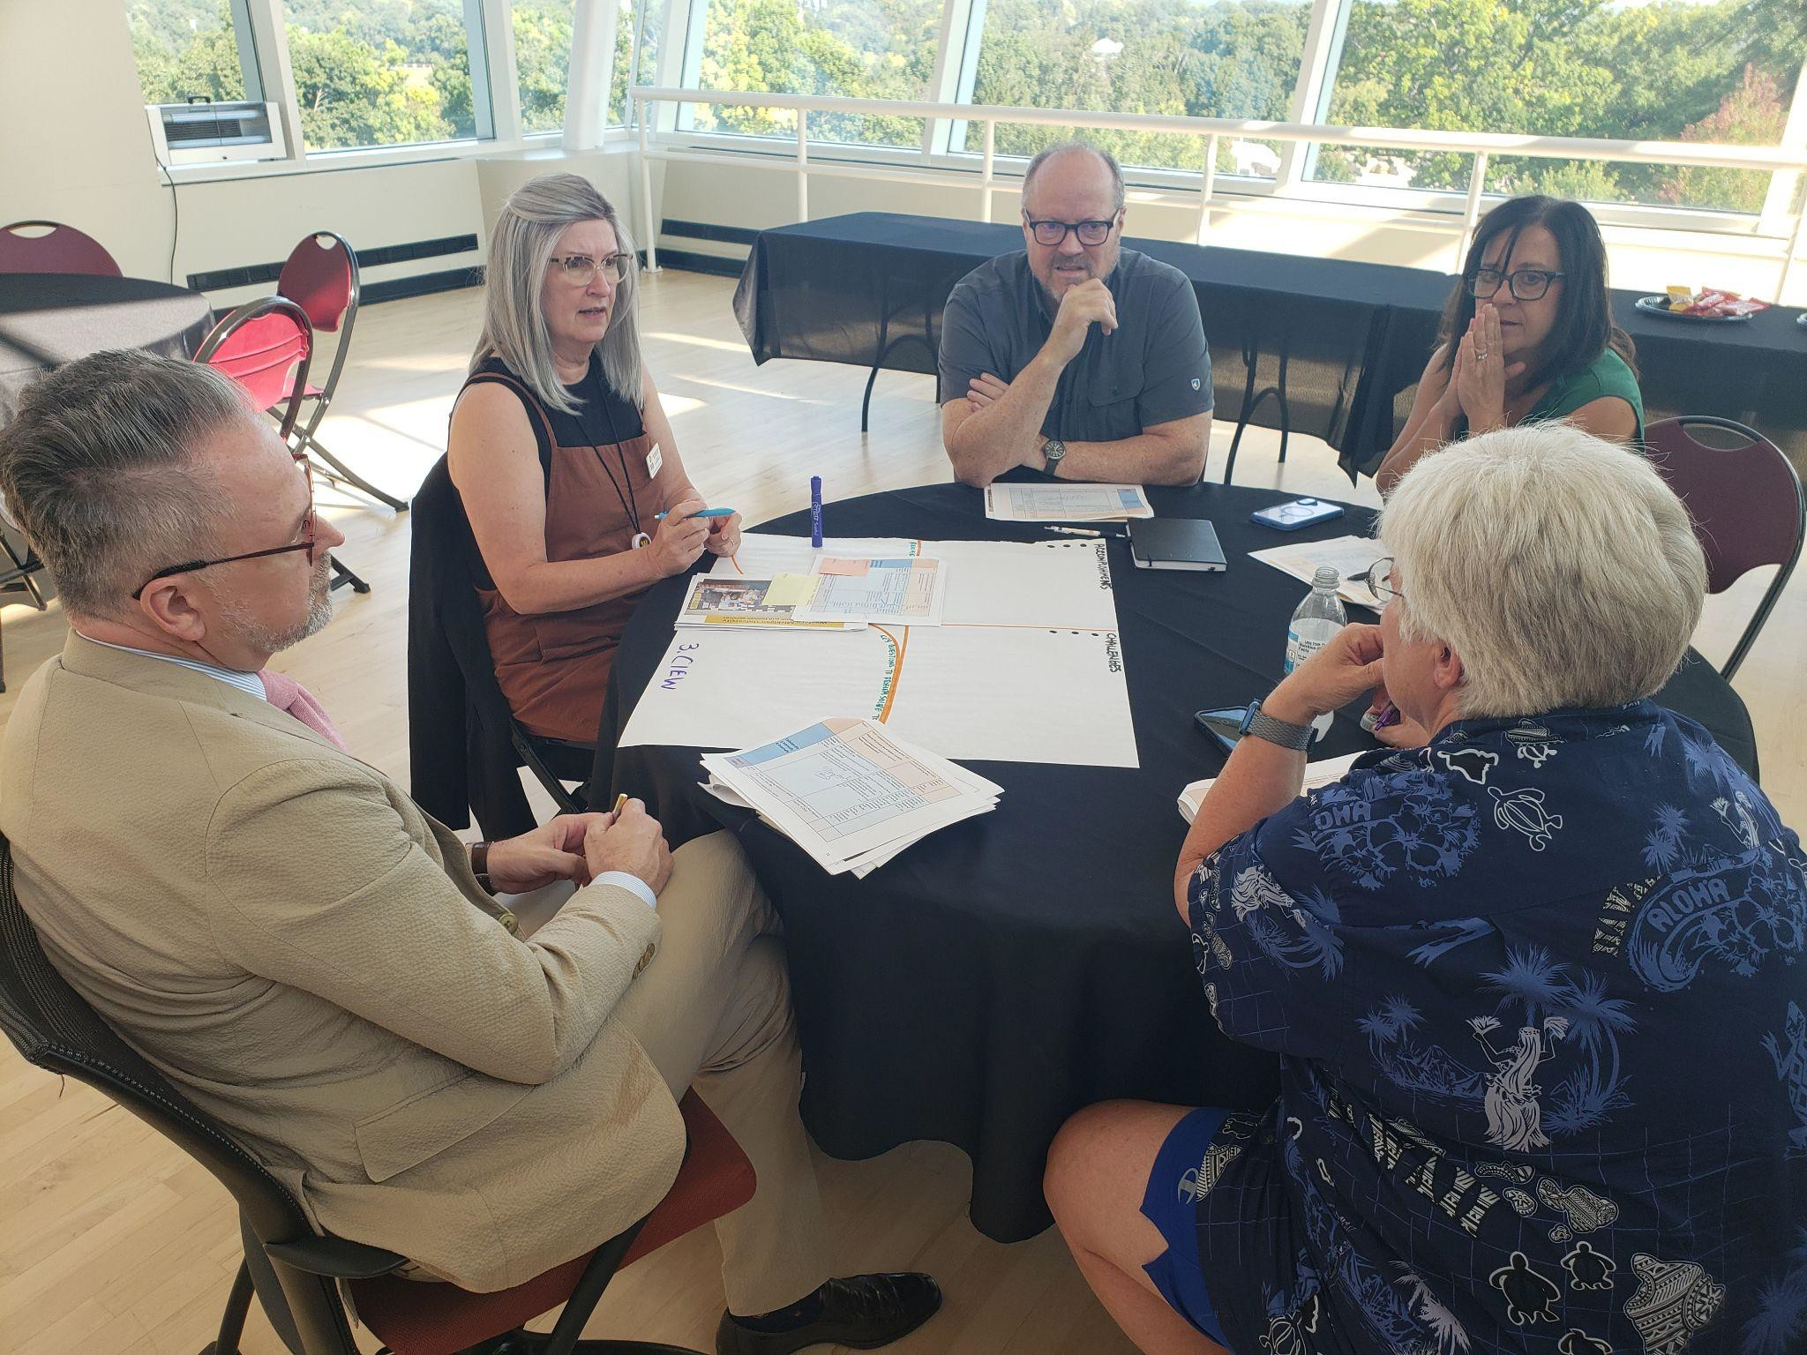
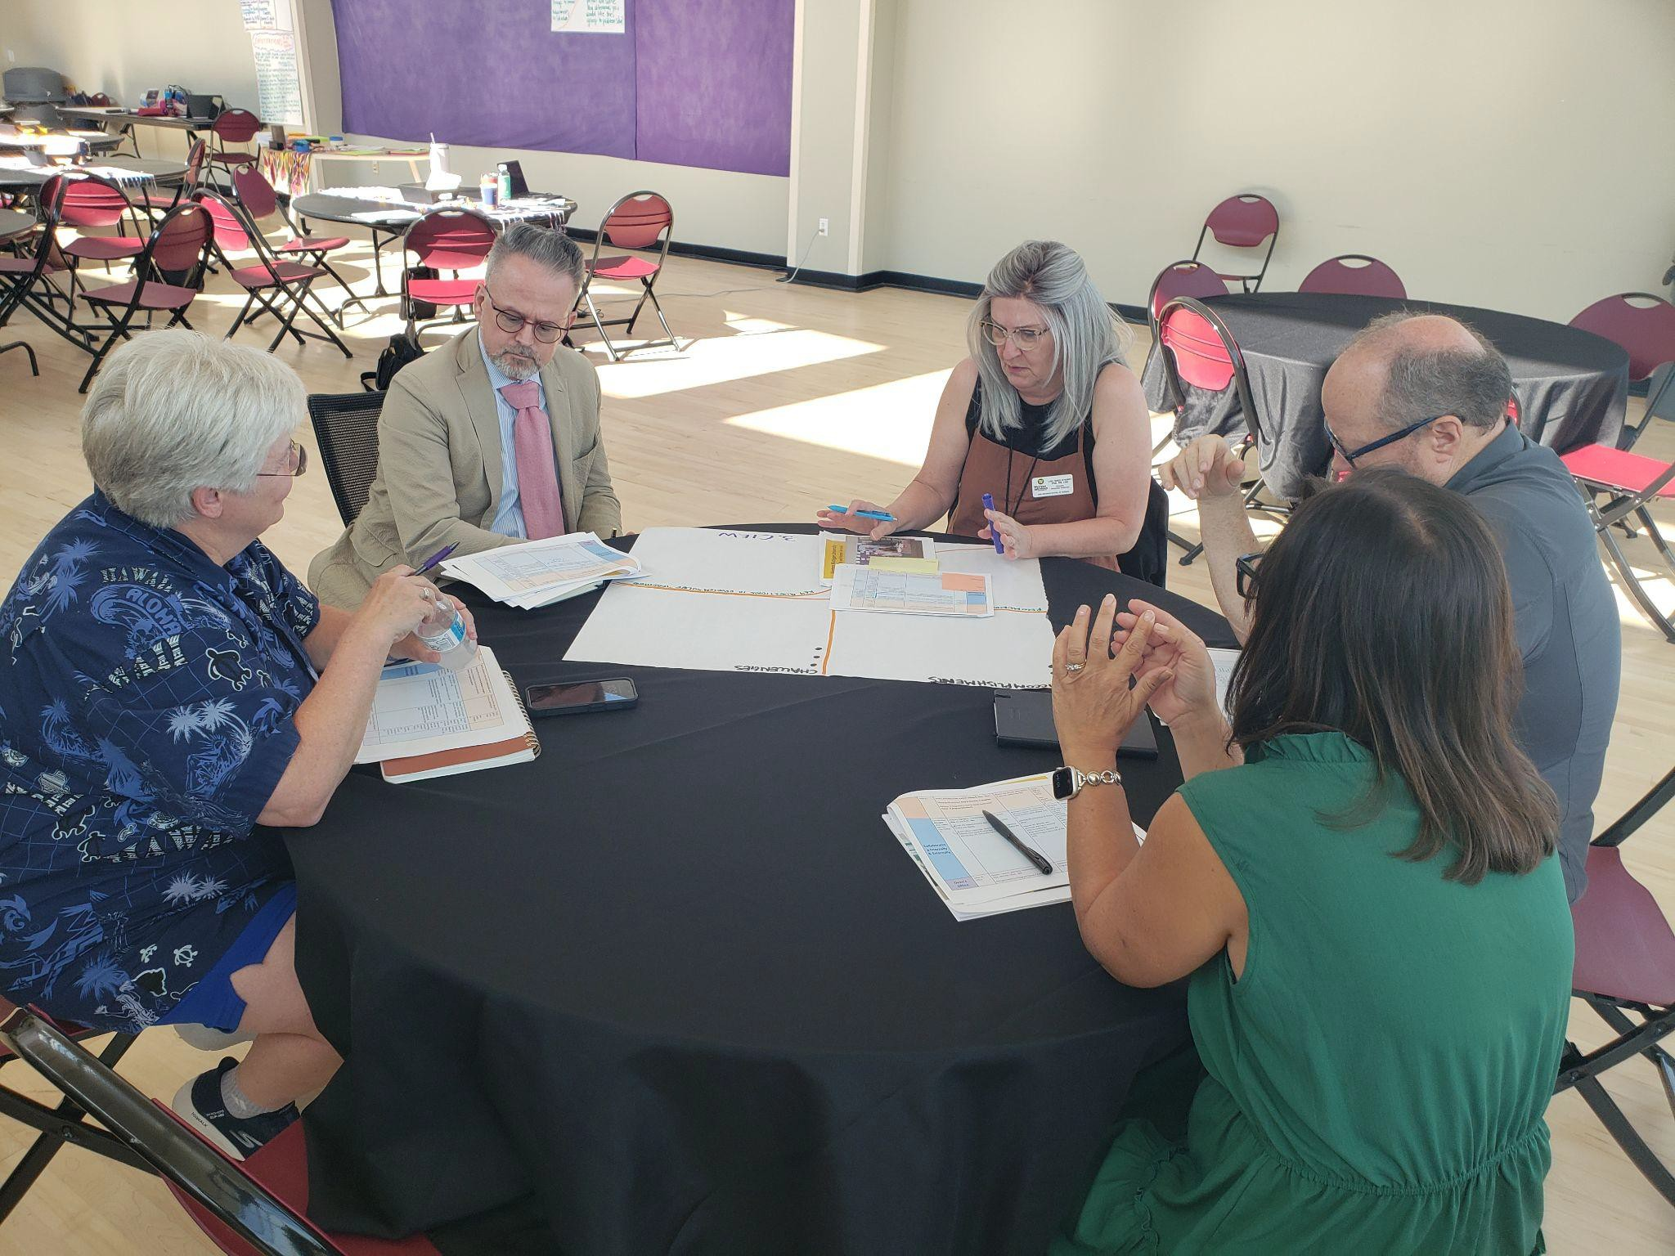
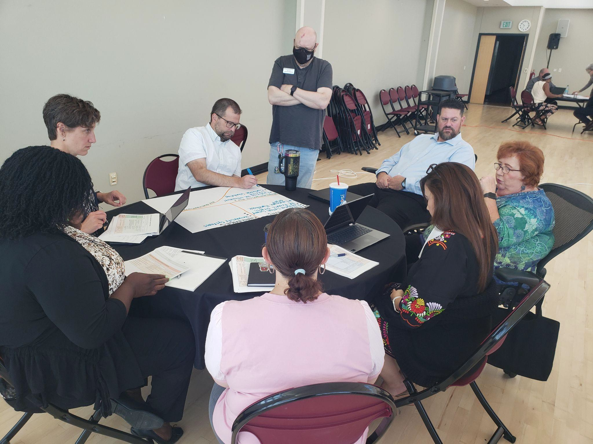

Engaging Faculty
What are innovative yet effective ways to engage our faculty in the adaptation of degree programs?

Communications with Faculty | Leadership Resourcing | Prototype and Try | Faculty Champions
Host interdepartmental forums  Series of Listening Sessions / Faculty Meetings | Leadership team will support and provide resources for implementation  College-Wide Innovation Committee with members from each Departmental Curriculum Comm. (Could be current college-wide Curric Comm)  Incentivize: - Faculty release time (workload), Reward collaboration through co-teaching opportunities etc.  Training Program for IPE | Come with proposed plan (and be flexible to change) | Faculty fellowship / champion
Meet (Associate or Dean) with faculty to introduce idea |  | Identify working model  (practical) | Gain initial support  from Key People
Planned interactions in Department meetings |  | Identify pilot - underenrolled,  core courses, good research
Listening sessions - group faculty by expertise - staff recording or leading the sessions  Ask faculty opinions transparently |  | PT / OT summer research course  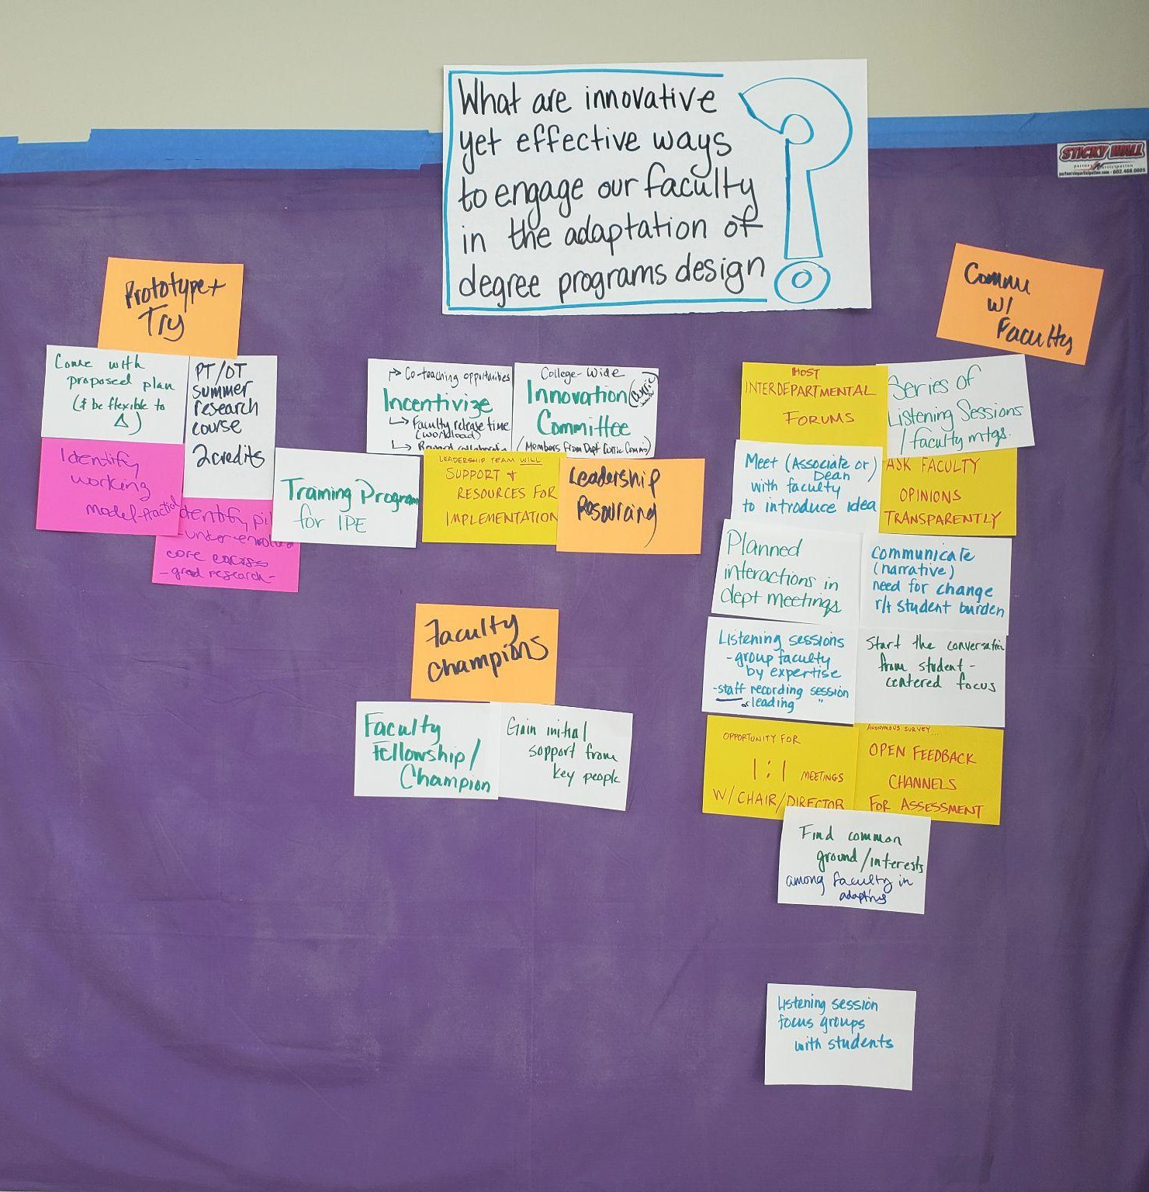  - 2 credits - could be part of the model
Communicate (narrative) need for change r/t student burden
Start the conversation form the student-centered focus
Opportunity for 1:1 meetings with Chair / Director
Anonymous survey - Open feedback channels for assessment
Find common ground / interests among faculty in adapting
Later…. Listening session focus groups with students

Year Two Implementation Timeline
Participants were asked to regather as Strategic Directions Teams and review the proposed deliverables that emerged from the thematic working groups, and add deliverables that build off the recommendations they made in their initial reflections on year one. They were then asked to ascribe a lead and a deadline to build the timeline below. Leads are bolded next to the task. The role of the lead is simply to ‘own’ the task in Envisio, do or delegate the work, track progress and be prepared to report back at check-in meetings.
Implementation Activities for Year Two , to be reviewed and updated Quarterly
Strategic Direction | Team Members | Q2 Oct - Dec ‘25 | Q3 Jan - Mar ‘26 | Q4 April - June ‘26 | Q1  Jul - Sep ‘26 | Year Three
(Re) Igniting College Pride, | *Ann*  Jill Kyoung Melinda Neale Scot | Submit lunch and learn proposal to Dean Melinda & Jill  Plan / Action items for Strategic Enrollment Scot (Form Strategic Enrollment Committee, Muti-faceted document including needs of dept, no one size fits all, review of existing data, reliable workforce data)  Integrate Workforce Needs Assessment Into Strategic Enrollment Plan Neale, Ann Dec | Start Lunch and Learn  Melinda & Jill  Messaging framework that appeals to  self-interest - Video Jill  Monthly out & about check-ins with people in and out of CHHS building by Directors and Chairs | Messaging framework that appeals to self-interest - Video Jill  Monthly out & about  check-ins with people in and out of CHHS building by Directors and Chairs | Messaging framework that appeals to self-interest - Video Jill  Monthly out & about  check-ins with people in and out of CHHS building by Directors and Chairs
Engagement  and Belonging |  | Messaging framework for faculty - Video clip from Lillian embedded in the Newsletter - Rules / Appeal to self-interest Jill
 |  | Create a google sheet for communication feedback from staff / faculty Crystal Dec
 |  | Monthly out & about check-ins with people in and out of CHHS building by Directors and Chairs
Modernizing our | *Drew*  Mariann | Form Space Committee of stakeholders - start monthly | Host open forums (1? 2?) with FOOD for feedback Robin, Amy, | Influence University Systems (Monthly Meetings ) All | Build measures in Envisio Platform (Community Behavioral Health Data) | Produce a recommenda tion for space

Infrastruc-ture | Amy Crystal Robin Joshua | meetings Robin & Amy  Finalize HR Training & Onboarding  Mariann  Schedule Richard C. for training (classroom schedule) Drew | Drew  Finalize Employee Handbook Drew, Mariann |  | Joshua, Crystal July | Drew with All
 | *Lisa*  Nancy Dawn | Compiled survey data into a database  Scot Oct  Listening Sessions (2) with faculty IPE Committee / Associate Dean Oct | Funding model for IPE created Dean / Associate Dean / Research Jan | Update IPE Website IPE Director April | Pilot - OT 6008/PT62080  Summer 2 2026 - Research Methods - 54 students - Room 1093 Nancy, Amy, Robin Summer 2, 2026 | Hold innovation committee
IPE  Curriculum  Collaboration |  | Dean / Associate Dean present (15 min) information about the need for Curriculum Adaptation to departments in Dept meetings Dean  / Assoc Dean Oct  IPE College Committee uses IPEC resources (assessment / training) IPE Director Dec | Completed needs  assessment for curriculum internally Scot Jan  Faculty workload credit for IPE innovative design - mechanism app / review IPE Director March |  | Data analysis - solution options Scot & IPE Director Sept  Student survey with Pilot  Su-II Research Course Based on SWOT Associate Dean for Research Aug
 |  | Decide on options (re: Curriculum Adaptations) Dean December
Community  Collaboration | *Chris*  Kieran Lillian Neale | IPE Director Hired Dean / Assoc Dean  Oct  Associate Dean Listening session with each individual Department (re: workload, space, study abroad, etc). Neale Dec  Workforce needs assessment plan  Neale & Ann Dec  CAST Tool assessment coordination | Funding model for IPE created Dean / Associate Dean / Research Jan  Completed needs assessment externally (linked to workforce needs assessment - including community opportunities / needs and services) Scot Jan | Update IPE Website IPE Director April

Dean's Office | Lillian Jasmine Alex Neale Chris Crystal | Confirm a University that implemented an EHR that we need / works Crystal, Christopher Nov  Determine the EHR that will meet UC needs Christopher, Crystal Dec  Feasibility assessment on AI  Chrisopher Dec  Refine Envisio and tie to WMU plan  Joshua, Enos Dec  Refine / define CHHS metrics for CHHS strategic plan Neale Dec | Create funding model for UC / students Christopher Feb | Create a guide on CAST for Behavioral Health Rob June | Finalize workload and implement plan Alex Summer  Determine appropriate budgets for units and develop methods and metrics for financial distribution Lillian Summer

Coordination
- Tasks will all be entered into Envisio each Quarter
- Once a quarter, the plan will be the subject of the College Council meeting and teams will check in on progress.
- Strategic Directions Teams will continue to meet monthly.
- The Community Collaboration Strategic Direction (broken off from what was formerly “Collaborating Internally and Externally”) will meet alongside the Dean’s Office (given that there is a lot of crossover in people) and continue to pursue both workstreams for now. That decision can be revisited at a future quarterly CheckIn
- The Role of Team Leads:
  - New Team Leads were identified for each Team (see bolded names). Expectations for their role include
  - Coordinating the monthly meetings
  - Updating Envisio (unless they’ve specifically delegated it to another team member who owns the task)
  - Updating Envisio at the Strategic Direction Level
  - Pulling Reports for the Strategic Direction for Quarterly check-in meetings
  - Adding (or ensuring it is being done by someone) new actions and ensuring they are tagged and / or cloned to the Strategic Plan.

……

