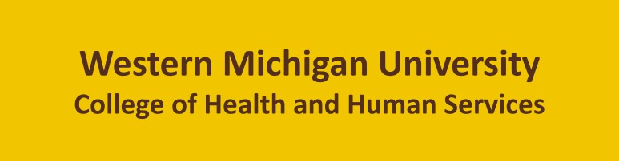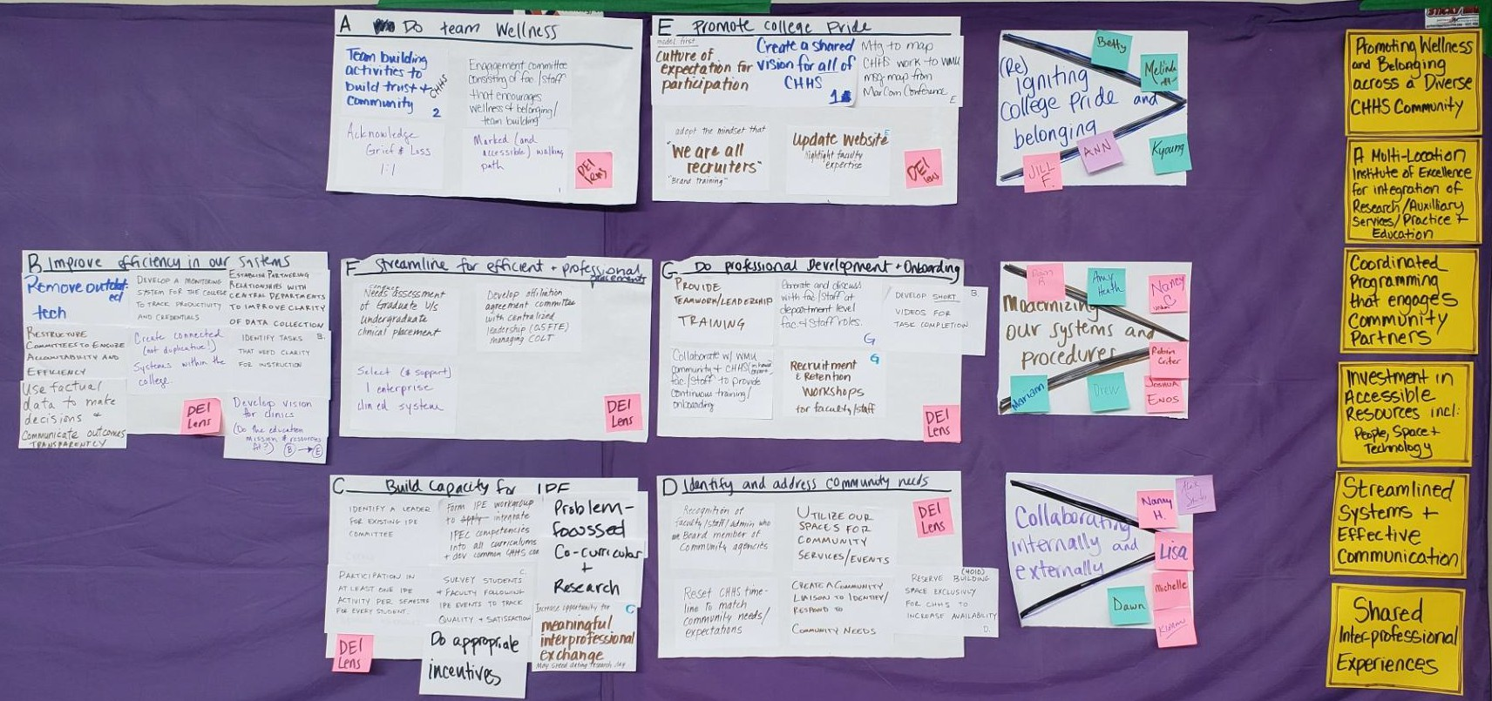

Table of Contents
Event Agenda 3
Reference Materials 3
Strategic Directions Workshop 4
Implementation Planning 6
Year One Implementation Timeline 8
Next Steps 9

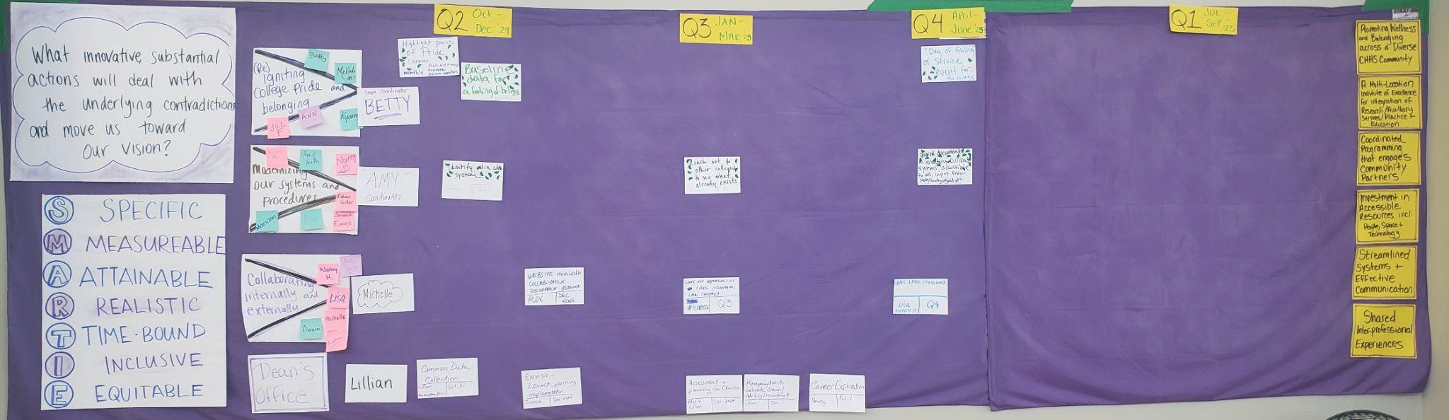

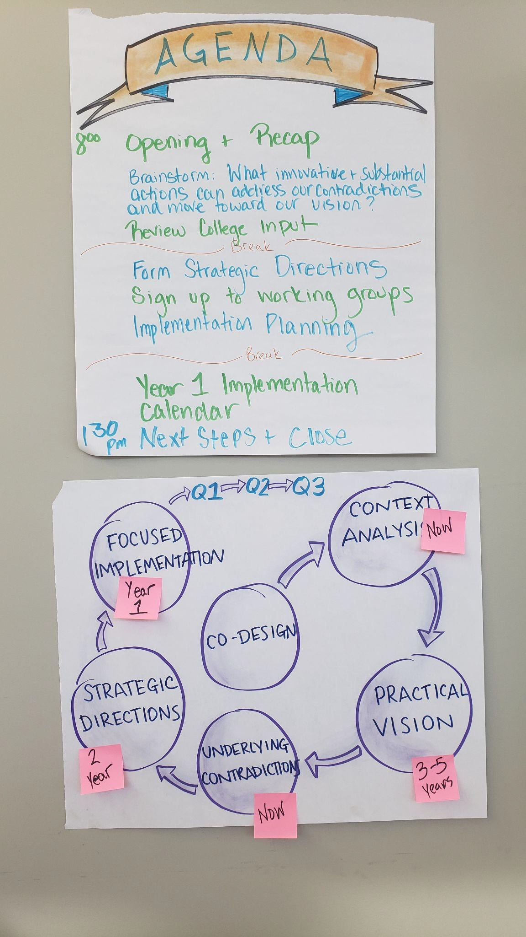
Event Agenda
The aims of this workshop were to incorporate the input of the previous consultations and use them to shape the strategies that the College intends to pursue to operationalize it’s Strategic Plan in the coming year.

The agenda for the session:
- Opening and Recap
- Brainstorm answers to: “What innovative and substantial actions can we pursue to address our contradictions and move toward our Vision?”
- Review All-College input and identify key answers repeated.
- Form Strategic Directions
- Form Strategic Directions Implementation Teams
- Conduct Implementation Planning
- Build a Year 1 Implementation Calendar
- Next Steps & Close

When asked about their expectations for the day, participants shared that they were interested in clear and specific goals, and to see the pieces of the process come together for an impactful product.

Reference Materials
Products of Multiple previous College consultations were incorporated into the agenda of the session and used to shape answers to strategic questions. These included:
Vision and Contradictions from Leadership Retreat ‘Quick Wins’ initial planning.
All College Hybrid Meeting products including:
- Vision Reflection and Success Measures - Consolidated
- Strategic Actions Brainstorm - Consolidated All-Staff Meeting and Survey Responses

Strategic Directions Workshop
The majority of the time during this event was spent in determining the actions that would shape the strategies that would make up the strategic directions that will anchor the next two years of effort. In order to do this in a way that honored the input gathered during the All-College event that happened the Friday prior, the process happened in several stages. The focus question for the workshop (documented below) was presented and participants read through their Vision and Contradictions products to remember what they were intending to address. After this, participants took part in a creativity exercise (uncommon uses for common objects!) to spark creative thinking. The first round of brainstorming focussed on ‘innovative’ ideas that may be catalytic in addressing multiple contradictions. These were posted and clarified. The next round of brainstorming was harvested from the input gathered at the All-College event. Participants read through a subsection of those comments and generated 3 to 5 actions implied by those ideas to inform the strategies. All these ideas were then clustered into strategies and again into overarching Strategic Directions. Participants were asked to review the input from the all college event one more time to ensure that there were no important actions proposed there were missing from the strategies. The result of this process can be seen below.

What innovative and substantial actions will address our contradictions and move us toward our vision?
Strategies |  |  | Strategic Directions
Support team wellness  - Teambuilding activities to build trust and community  - Acknowledge grief & loss 1:1  - Engagement committee consisting of fac./staff that encourages wellness + belonging/ team building  - Marked (and accessible walking path) | Promote college pride  - Culture of expectation for participation  - Create a shared vision for all of CHHS  - Mtg to map CHHS work to WMU msg map from MarCom Conference  - Adopt the mindset that “we are all recruiters” “Brand training”  - Update website highlight faculty expertise |  | (RE)IGNITING COLLEGE PRIDE AND BELONGING
Improve efficiency in our systems  - Remove outdated tech  - Restructure committees to ensure accountability and efficiency  - Use factual data to make decisions + communicate outcomes transparency  - Develop a monitoring system for the college to track productivity and credentials  - Create connected (not duplicative!) systems within the college  - Establish partnering relationships with central departments to improve clarity of data collection  - Identify tasks that need clarity for instruction  - Develop vision for clinics (Do the education mission & resources fit?) | Streamline for efficient and professional placements  - Conduct needs assessment of Graduate v/s undergraduate clinical placement  - Select (& support) 1 enterprise clin ed system  - Develop affiliation agreement committee with centralized leadership )0.5 FTE) managing COLT | Do professional development and onboarding  - Provide teamwork/leadership training  - Collaborate w/ WMU community + CHHS (in house expert) fac./staff to provide continuous training/onboarding  - Recruitment & retention workshops for faculty/staff  - Develop short videos for task completion | MODERNIZING OUR SYSTEMS AND PROCEDURES
Build capacity for IPE  - IDentify a leader for existing IPE committee  - Participation in at least one IPE activity per semester for every student  - Form IPE workgroup to integrate IPEC competencies into all curriculums + dev common CHHS  - Survey students + faculty following IPE events to track quality + satisfaction  - Do appropriate incentives  - Problem-focused  - Co-curriculuar + research  - Increase opportunity for meaningful interprofessional exchange. May speed dating research day |  | Identify and address community needs  - Recognition of faculty/staff/admin who are board member of community agencies  - Reset CHHS timeline to match community needs/expectations  - Utilize our spaces for community services/events  - Create a community vision to identify / respond to community needs  - Reserve building (4010) space exclusively for CHHS to increase availability | COLLABORATING INTERNALLY AND EXTERNALLY

Implementation Planning
Once the overarching Strategic Directions (Strategic Goal Areas) for the coming two years were identified, participants signed up to the area they would champion. They then reviewed the proposed actions, with a lens on the current reality and proposed what success measures to work towards, and what actions to pursue. These were presented to the whole group who were invited to ask questions of clarity, add their thinking and

then help prioritize the actions they would like to see added to the implementation calendar. The asterisks (*) below represent ‘votes’ towards prioritization.

Strategic Direction: (RE)IGNITING COLLEGE PRIDE AND BELONGING
Team Members: Betty Ann, Jill, Kyoung, Melinda & Trevor
Current reality | Year One Accomplishments | Year Two Success Measures
+ Spaces student voice  - Disconnect disengage limited recognition Opp: #1 I.D. at all college  * ^ college-wide events (movie nights) New leadership supporting wellness during  Threat: time | - Highlight points of pride (Bronco achievements) monthly newsletter atrium monitors **********  - 4 College-wide wellness/social events  - Quarterly birthday celebration *  - Once a semester highlight a couple depts to help w/ recruitment*  - Designated wellness space for monthly wellness activity x3 ***  - Baseline data for a feeling of belonging  *********  - 15 faculty/ staff highlight bios before 6/30 ***  - “Day of Giving” or service event for the college ****** | - Use of existing space for wellness  - Social events to promote belonging  - Ice cream social  - Chili cook-off invite external partners + facilitators  - Crafts to donate etc.  - Fundraiser  - Music/karaoke  - Volunteer groups  - Calendar of events by semester  - External news recognition

Strategic Direction: MODERNIZING OUR SYSTEMS AND PROCEDURES
Team Members: Amy, Dawn R, Drew, Joshua, Robin, Mariann, Nancy C
Current reality | Year One Accomplishments | Year Two Success Measures
S- Some collaboration already. Current examples in place already  O- Skills + resources ripe for IPE/research  W- No organized master plan. No facilitator. Communication  O-People ready to work together  T- Apathy. Schedules/time, logistics S- Current CHHS IPE Committee | - Established CHHS Community advisory board ****  - Website highlights collaborative research & service initiatives *  - Survey students to determine % who participate in IPE  - Look for opportunities all/most CHHS programs can impact  - Identify 3 foci(?) for projects  ***********  - IPE CHHS Committee purpose/scope  - IPEC crosswalk curriculum map of all CHHS departments********* | - Impact a recognized problem in the community  - Developed 3 CHHS/IPE courses each program uses at least 1 in their curriculum  - CHHS IPE Center of excellence 1 FTE leader 0.5 FTE admin

Strategic Directions: COLLABORATING INTERNALLY AND EXTERNALLY
Team Members: Michelle, Alex, Dawn, Kieran, Lisa, Nancy H.
Current reality | Year One Accomplishments | Year Two Success Measures
- Awareness of challenges Experienced staff and faculties  - Too many systems  - Familiarity with existing systems  - Materials exist  - Upset status quo | - Shared document to inventory current systems, accessible to all, input from  - Make living documents **  - Reach out to other colleges to see what already exists *******  - Identify clin ed system**********  - Build training for users (multimodal)  *** | - Have a manual of procedures (employee handbook)  - Unified Clinical Education & placement system in place  - Established central hub @ college level (systems)  - Established central hub @ college-level (students)  - Multi-modal training resources

Year One Implementation Timeline

Implementation Activities for Year One, to be reviewed and updated Quarterly
Strategic Direction | Team Members | Q2 Oct - Dec ‘24 | Q3 Jan - Mar ‘25 | Q4 April - June ‘25 | Q1  Jul - Sep ‘25
(Re) Igniting College Pride and Belonging | Coordinator: Betty Ann, Jill, Kyoung, Susan, Melinda & Trevor | Highlight points of Pride (Bronco Achievements) Monthly (Newsletter, Atrium Monitors) Jill - Ongoing  Baseline date for a ‘feeling of Belonging’ Ann & Kyoung |  | “Day of Giving” or service event for the College Betty / Trevor
Modernizing our Systems and Procedures | Coordinator: Amy Dawn R, Drew, Joshua, Robin, Mariann, Nancy C | Identify Clin Ed System Joshua | Reach out to other colleges to see what already exists Drew | Inventory of current systems - in a shared document, accessible to all, with input from staff/faculty/adjunct, etc & distributed work Nancy
Collaborating Internally & Externally | Coordinator: Michelle Alex, Dawn, Kiernan, Lisa, Nancy H. | Website Highlights - Collaborative research / service Alex - Dec | Look for opportunities - CHHS programs can impact Michelle | CHHS IPEC Crosswalk Lisa, Nancy H
Dean's Office | Lillian & Office | Common Data Collection Lillian, Mariann, Nancy, Alex - Oct 31  Envisio - Launch, planning, implementation Joshua - Dec  Assessment & planning for clinics  Alex & Lillian - Dec | Reorganization to integrate Comm / Advising / Recruitment Lillian - Jan 1  Career exploration Nancy - Feb 1

Next Steps
The session was closed with a commitment to share the product of the days planning with the college and discussion about the rollout of the Envisio project management software as a monitoring and accountability tool. Quarterly check-ins were agreed to and Strategic Directions team coordinators were asked to ensure each team filled in detailed planning worksheets for any key accomplishments within the first quarter.

