ScholarshipUniverse Instructions

ScholarshipUniverse is WMU’s tool for students to identify and apply for scholarships, both institutional and private, that they might qualify for.
To access the system please visit: wmich.scholarshipuniverse.com. Here, you will be asked to sign in with you Bronco NetID and password.
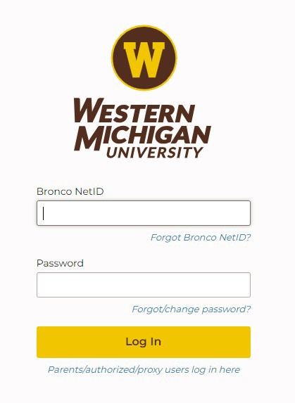

If this is your first time accessing the system, you will have the option to provide your phone number to receive SMS text message updates regarding upcoming deadlines and other important information from ScholarshipUniverse. To use the system for the first time, click on “I’m Ready!” and begin answering questions.
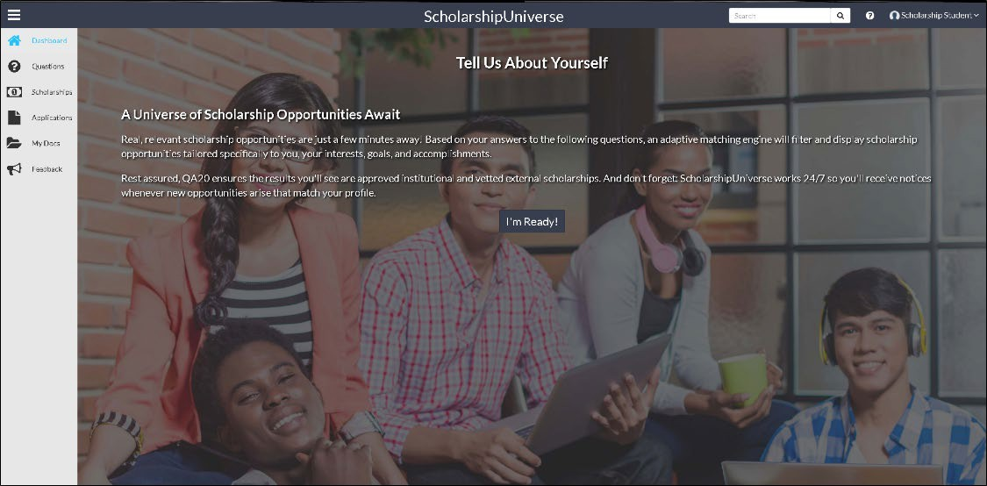

If you have used ScholarshipUniverse before, you will be directed to your student dashboard and should click the grey Banner in the top middle of the screen to answer new screening questions. You can also access these questions in the “Questions” tab on the upper left-hand side of the screen.

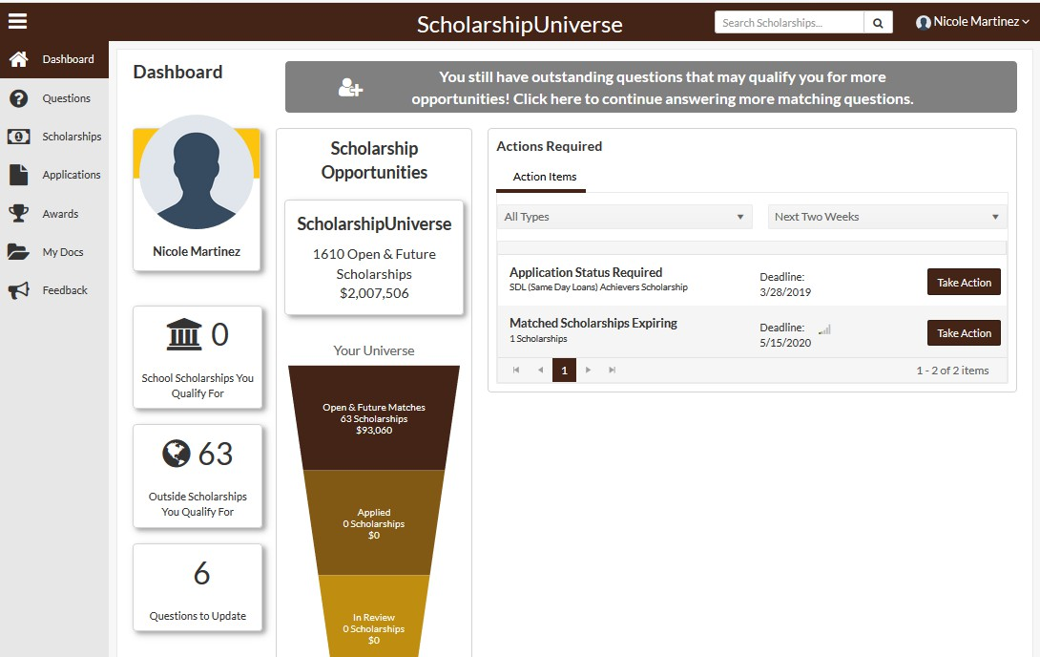

The ScholarshipUniverse system already knows some things about you, like your major, GPA, and financial information you used to complete the Free Application for Federal Student Aid (FAFSA). But your responses to questions in the system will help determine what scholarships you may qualify for. The more questions you answer, the more likely you are to find a scholarship that may be a good fit!

To view suggested scholarships that you may qualify for, you can click “Matches” in the Questions tab.
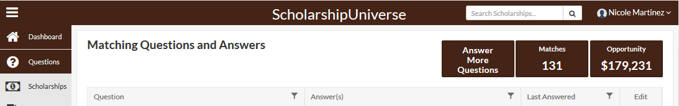

Take some time to review your matches. If you would like to apply to a private/external scholarship you can click the apply button and you will be redirected to the website and application of that offer. If you would like to apply to an internal/WMU scholarship that is listed in the system, you can click on apply and submit all of your application materials here, in one place!

You can also use the system to search for a specific scholarship. (However, please keep in mind that not all WMU scholarships are available in ScholarshipUniverse at this time). You can click on the Scholarships tab and then select the Sort/Filter option on the top right corner. You can sort by internal School Scholarships, search by name, or filter for specific College/Department.

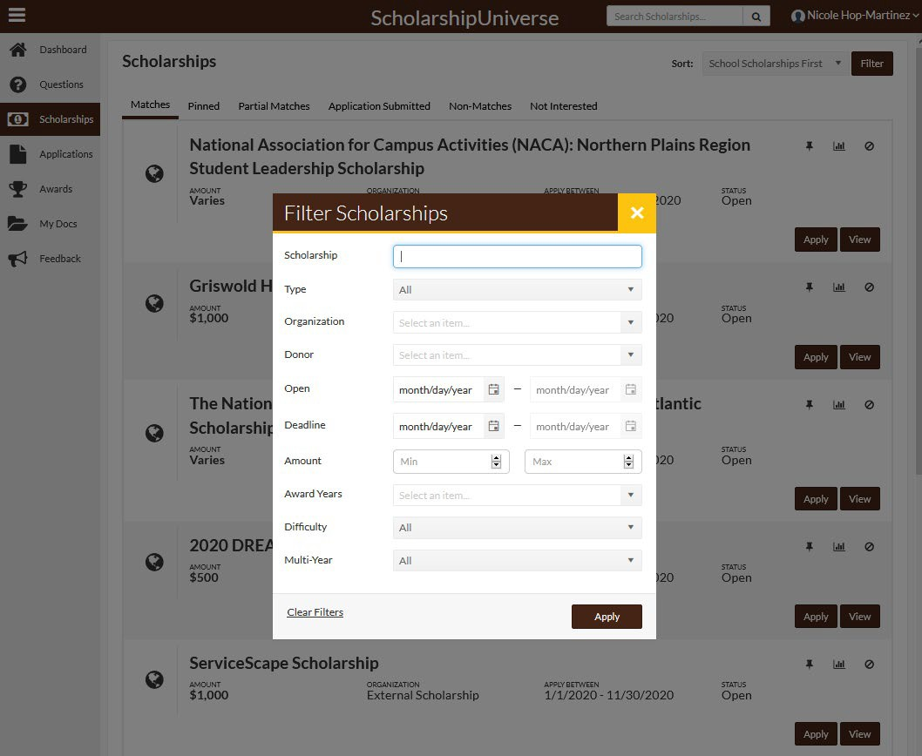

Keep in mind that you must meet minimum matching requirements as established by the offering department to be able to apply to many scholarships.
It is recommended that you log in to ScholarshipUniverse periodically to stay up to date on any new scholarships that are posted and to monitor the status of the applications you have already submitted. During the peak scholarship application season (typically late Fall through mid-Spring) it is recommended to log in more frequently.

