Operationalizing

the CHHS Strategic Plan

CHHS Strategic Planning Process

Progress Meetings:
6 months 9 months
3 months

Inventory of Trends & Environmental Scan

Committing to the One Year Project Implementation Calendar
1 year

Brainstorming
Action Ideas and Developing

Shared Context Analysis
& Design

Identifying Underlying
Creating Practical Goals/Vision: 3-5 years

Strategic Directions
Contradictions




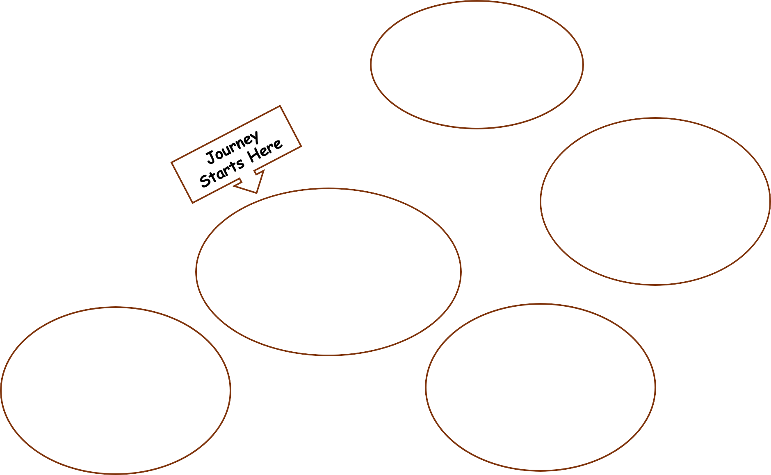





Source: https://www.ica-usa.org/consult.html

We worked with the CHHS Strategic Plan that was finalized in November 2023: | We identified cross-cutting areas for Practical Goals/Vision by answering this question:  What do we want to see in place in 3 to 5 years as we operationalize our strategic plan? | Then we identified challenges and our part in them that kept us from reaching our vision:  What is blocking us from achieving our Vision?
Seven Pillars: Academic Excellence Community Building Diversity, Equity, and  Inclusion Internationalization Research & Creative  Scholarship Sustainability Well-being | Operational Vision:  Promotion of Wellness and Belonging across a Diverse CHHS Community  A multi-location Institute of Excellence for  Integration of Research/Auxiliary Services / Practice & Education  Coordinated Programming that Engages Community Partners  Investment in Accessible Resources incl:  People, Space & Technology Streamlined Systems and Effective  Communication  Shared Interprofessional Experiences | Contradictions:  Residual trauma & outdated narratives contribute to unhealthy patterns of work  Staff & faculty disengagement linked to broken expectations and mis-incentives  Short-term, comfortable solutions leading to outdated and Inefficient systems  Incohesive leadership that is under-supported leads to protectionism  Need to solve community problems and not just our own (interests)  Ambiguous & ever-changing plans lead to  a laissez-faire culture of accountability

Next steps:
- Collecting data and additional information on different systems through which we do our work
- Exploring ways to enhance communications, outreach, marketing and advising
- Engaging with faculty and staff for input and feedback through meetings and surveys
- All College Meeting, morning of September 27

