
Strategic Plan 2023-2033

Mission
We engage every person in an inclusive and supportive academic environment that inspires compassion, integrity, and advocacy.

Vision
We prepare all learners to thrive in health and human services careers that are high in purpose, high in satisfaction, and unsurpassed in impact.

In developing the Strategic Plan for the College of Health and Human Services, we follow the five core values established for Western Michigan University:
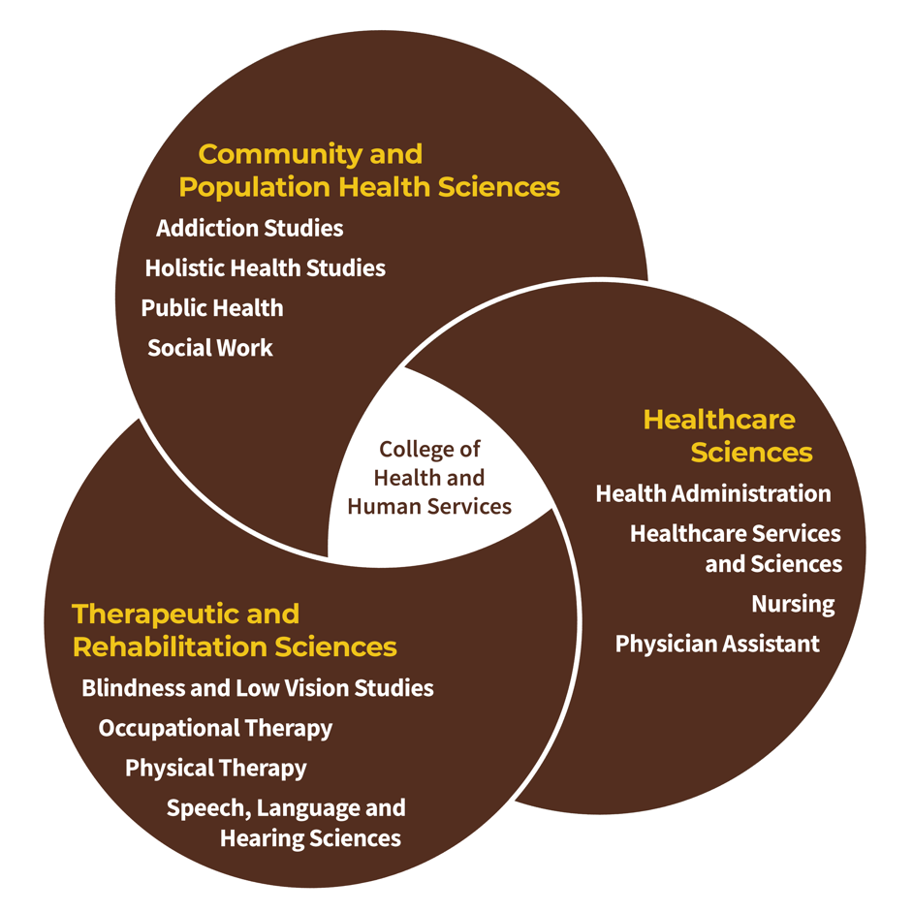
- Community-Engaged
Education
Experiential,
Interprofessional and Inclusive
- Discovery-Driven
- Equity-Centered
- Learner-Focused
- Sustainability-Guided

CHHS Career Pathways Model

ACADEMIC EXCELLENCE
Goal: We empower one another to develop the skills and knowledge needed to succeed in life and make a positive difference in the world by leveraging our college’s academic strengths.

  - Objective 1: Provide a high-quality education consistent with best practices in the scholarship of teaching and learning
  - Objective 2: Prioritize student success initiatives for successful enrollment and improved retention and persistence from academic programs of choice
  - Objective 3: Offer curricular and co-curricular opportunities that are experiential, inclusive, and interprofessional, resulting in an immersive education for our students
  - Objective 4: Focus our academic programs and align our college along the Career Pathways Model

COMMUNITY BUILDING
Goal: We strengthen our relationships with those we serve by cultivating a culture grounded in communication, collaboration, and engagement that fosters a sense of belonging, safety, and support.

  - Objective 1: Deepen and broaden our community partnerships to strengthen the bond between our college and the greater community
  - Objective 2: Build internal community among all students
  - Objective 3: Build internal community among all CHHS employees through sustained initiatives and recognition of contributions and achievements
  - Objective 4: Facilitate consistent, transparent, and accessible communication between CHHS and those we serve to strengthen our local, regional, and global partnerships

DIVERSITY, EQUITY AND INCLUSION
Goal: We actively create and continuously invest in building an inclusive and equitable environment where every member of our community feels like they belong and has access to the resources they need to thrive.

  - Objective 1: Recruit, retain and graduate a diverse student body while steadily eliminating disparities in graduation rates
  - Objective 2: Hire and retain faculty, staff, and administrators that better reflect and support the changing identities of the student population in the US.
  - Objective 3: Provide widespread and accessible diversity curriculum and co-curricular touchpoints for all students throughout their years in CHHS
  - Objective 4: Support innovative programs for students from underserved and underrepresented populations

INTERNATIONALIZATION
Goal: We provide extensive, renowned global learning opportunities to all community members to develop cross-cultural competence and enhance understanding of and contribution to a more peaceful, prosperous and sustainable world.

  - Objective 1: Strengthen faculty, staff, and student opportunities to engage in collaborative global learning experiences
  - Objective 2: Develop and refine faculty and staff global engagement programs and opportunities that bolster participating in international activities
  - Objective 3: Integrate and prioritize diversity, equity, and inclusion strategies into all international initiatives
  - Objective 4: Advance a culture of internationalization and global engagement by removing barriers through policies, strategy, and programming

RESEARCH AND CREATIVE SCHOLARSHIP
Goal: We create and support research and scholarship opportunities through the CHHS Office for Research (CHHS-OR) with focus on enhanced engagement, productivity, and funding.

  - Objective 1: Increase engagement by multiple stakeholders in CHHS research
  - Objective 2: Improve CHHS’ capacities for production and funding of creative and scholarly work
  - Objective 3: Increase productivity and visibility of CHHS scholarly work
  - Objective 4: Increase applied and received external funding in the College

SUSTAINABILITY
Goal: We integrate environmental and economic sustainability into all aspects of college functions.

  - Objective 1: Promote climate change literacy via co-curricular activities
  - Objective 2: Improve economic sustainability of CHHS Unified Clinics through continuous improvement in practices
  - Objective 3: Enhance donor engagement to maintain strong relationships with new and existing donors
  - Objective 4: Increase external donor funds to support the College’s mission, programs, and initiatives

WELL-BEING
Goal: We safeguard the overall health of our community by embedding well-being into all aspects of our culture, administration, operations, and academics.

  - Objective 1: Increase opportunities for engagement in wellness activities for students, faculty, and staff
  - Objective 2: Provide effective, equitable opportunities for all to build the personal capacity, health information fluency, and life-enhancing skills needed to thrive
  - Objective 3: Provide needed and accessible health and wellness services within the Unified Clinics
  - Objective 4: Enhance the spaces where we learn, work, and connect so they are more conducive to safety and accessibility

