GLOW Errors – Clear Browser Cache
Many PeopleSoft and GLOW issues can be solved by clearing your browser cache and temporary files. If you are having issues with PeoplSoft or GLOW It is recommended to try and clear your browser cache first. Below are instructions for how to do this in Microsoft Edge and Google Chrome browsers.

Microsoft Edge
- From the Edge toolbar click the three-dot menu next to the search bar:

- Then select “Delete Browsing Data” (alternatively you can press “Ctrl + Shift + Delete” on your keyboard).
- Make sure “Cookies and other site data” and “Cached images and files” is checked, also verify that the time range is set to “All Time”:
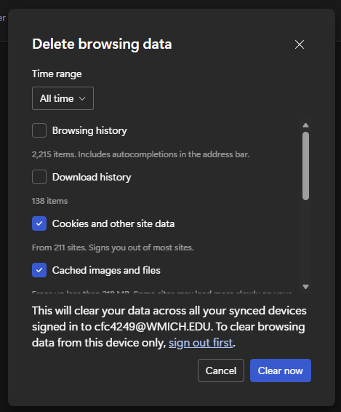
- Click “Clear Now”
- Restart your browser and log into GLOW.

Google Chrome
- From the Chrome toolbar click the three-dot menu next to the search bar:

- Then select “Delete Browsing Data” (alternatively you can press “Ctrl + Shift + Delete” on your keyboard).
- Make sure “Cookies and other site data” and “Cached images and files” is checked, also verify that “All Time” is checked:
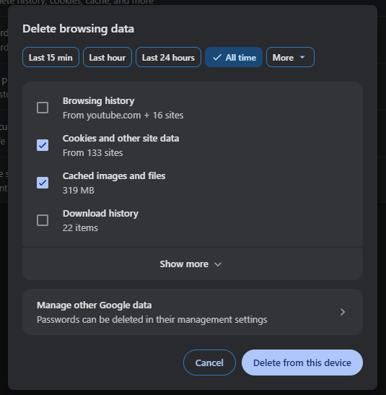
- Click “Delete from this device”
- Restart your browser and log into GLOW.

