
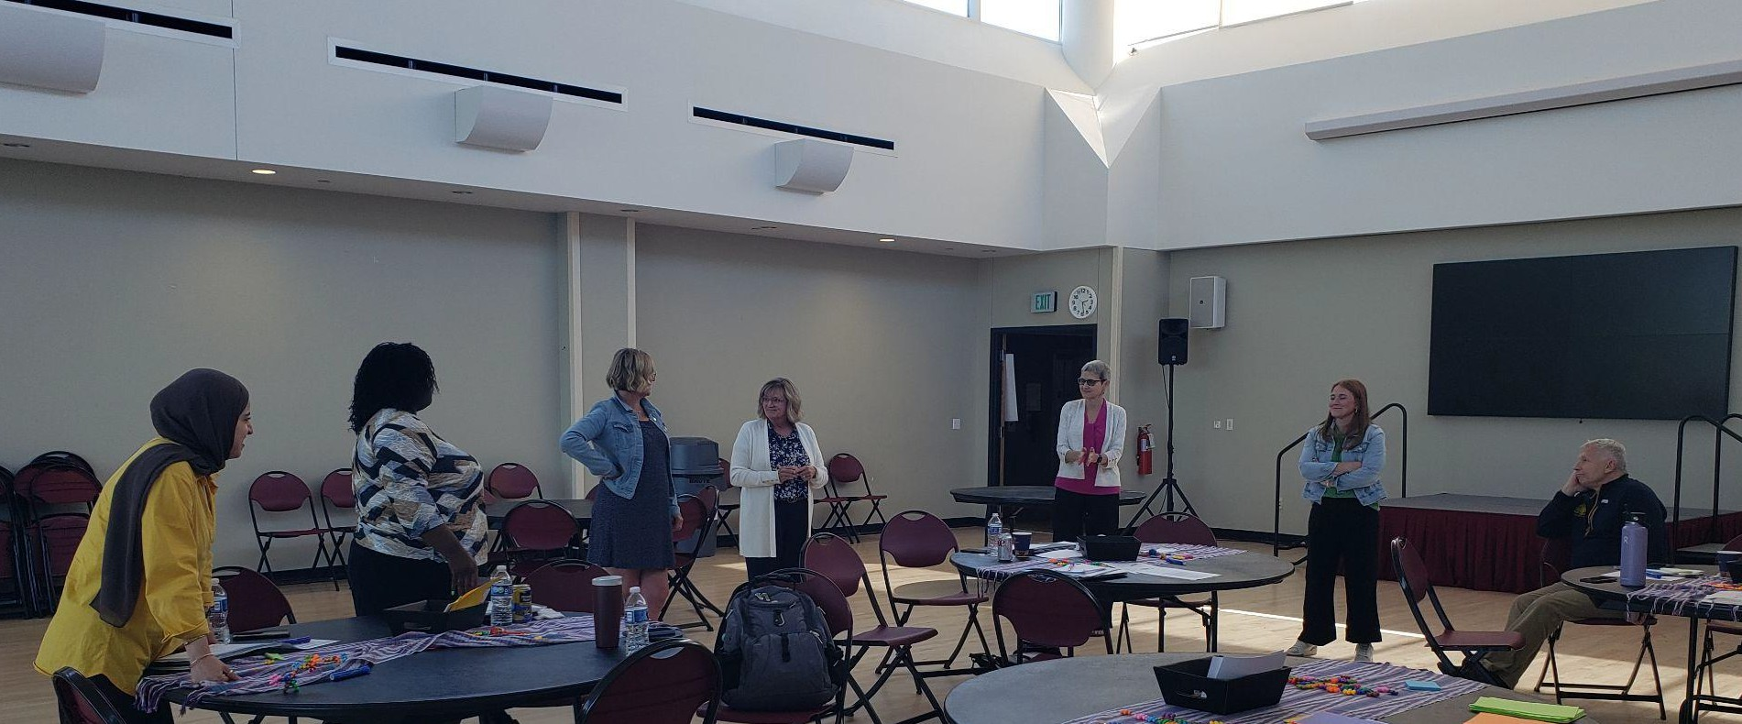


Facilitated by Alisa Oyler, Partners in Participation

Table of Contents
Table of Contents 1
Aims / Agenda 2
Hopes for Our Collaborative 2
Decisions and Strategies to be Informed 2
Overall Aim of the Collaborative 2
WHAT Data? 3
WHAT Data? 4
Key Questions to Address 5
Data 6

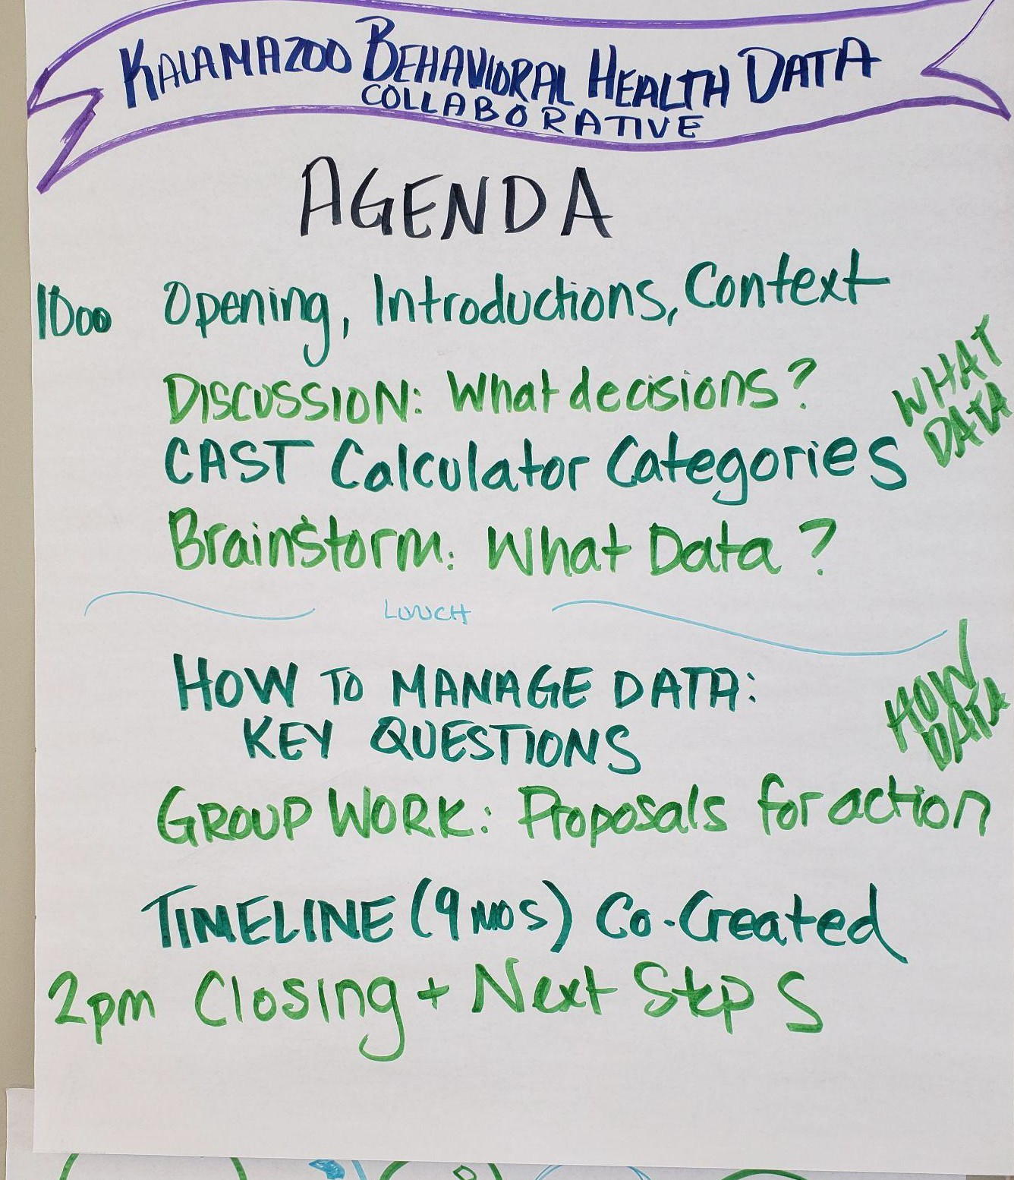
Aims / Agenda
Agenda for the day:
10:00am Opening, Introductions, Context
Discussion: What decisions could be informed by the data? CAST Calculator Categories
Brainstorm: WHAT Data Needs to fed into the calculator? Lunch
HOW to manage Data - Key Questions to address. Group Work: What actions will we take?
Develop Workstreams
Build Timeline for Implementation
2:00pm Closing & Next Steps

Hopes for Our Collaborative
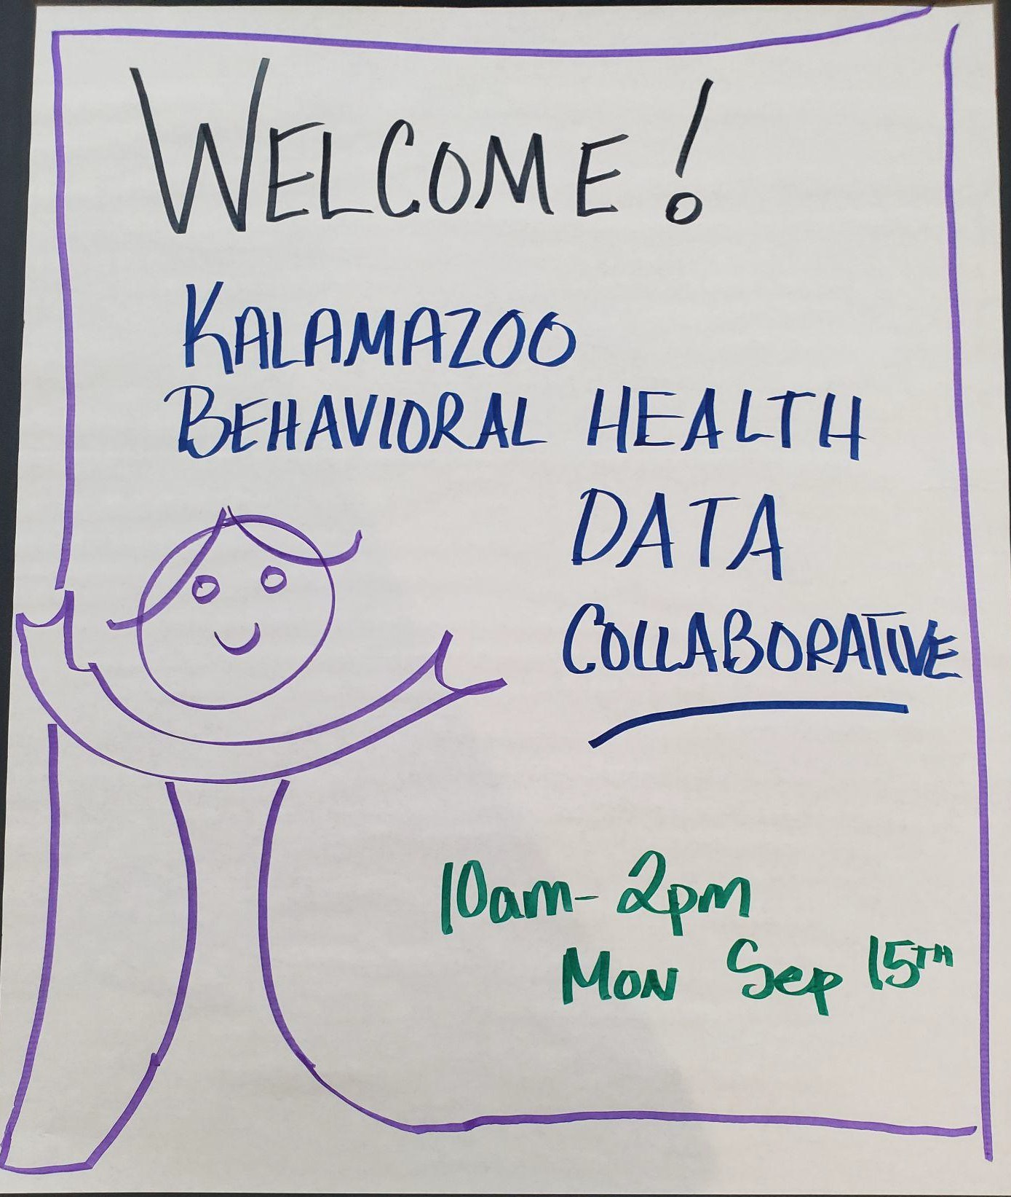
Jeff Patton opened the event with an update on some key issues occurring in the state related to mental and behavioral health. Then Lillian Smith shared about the grant that created the Kalamazoo Behavioral Health Data Collaborative, which led to us identifying
hopes for the Collaborative:
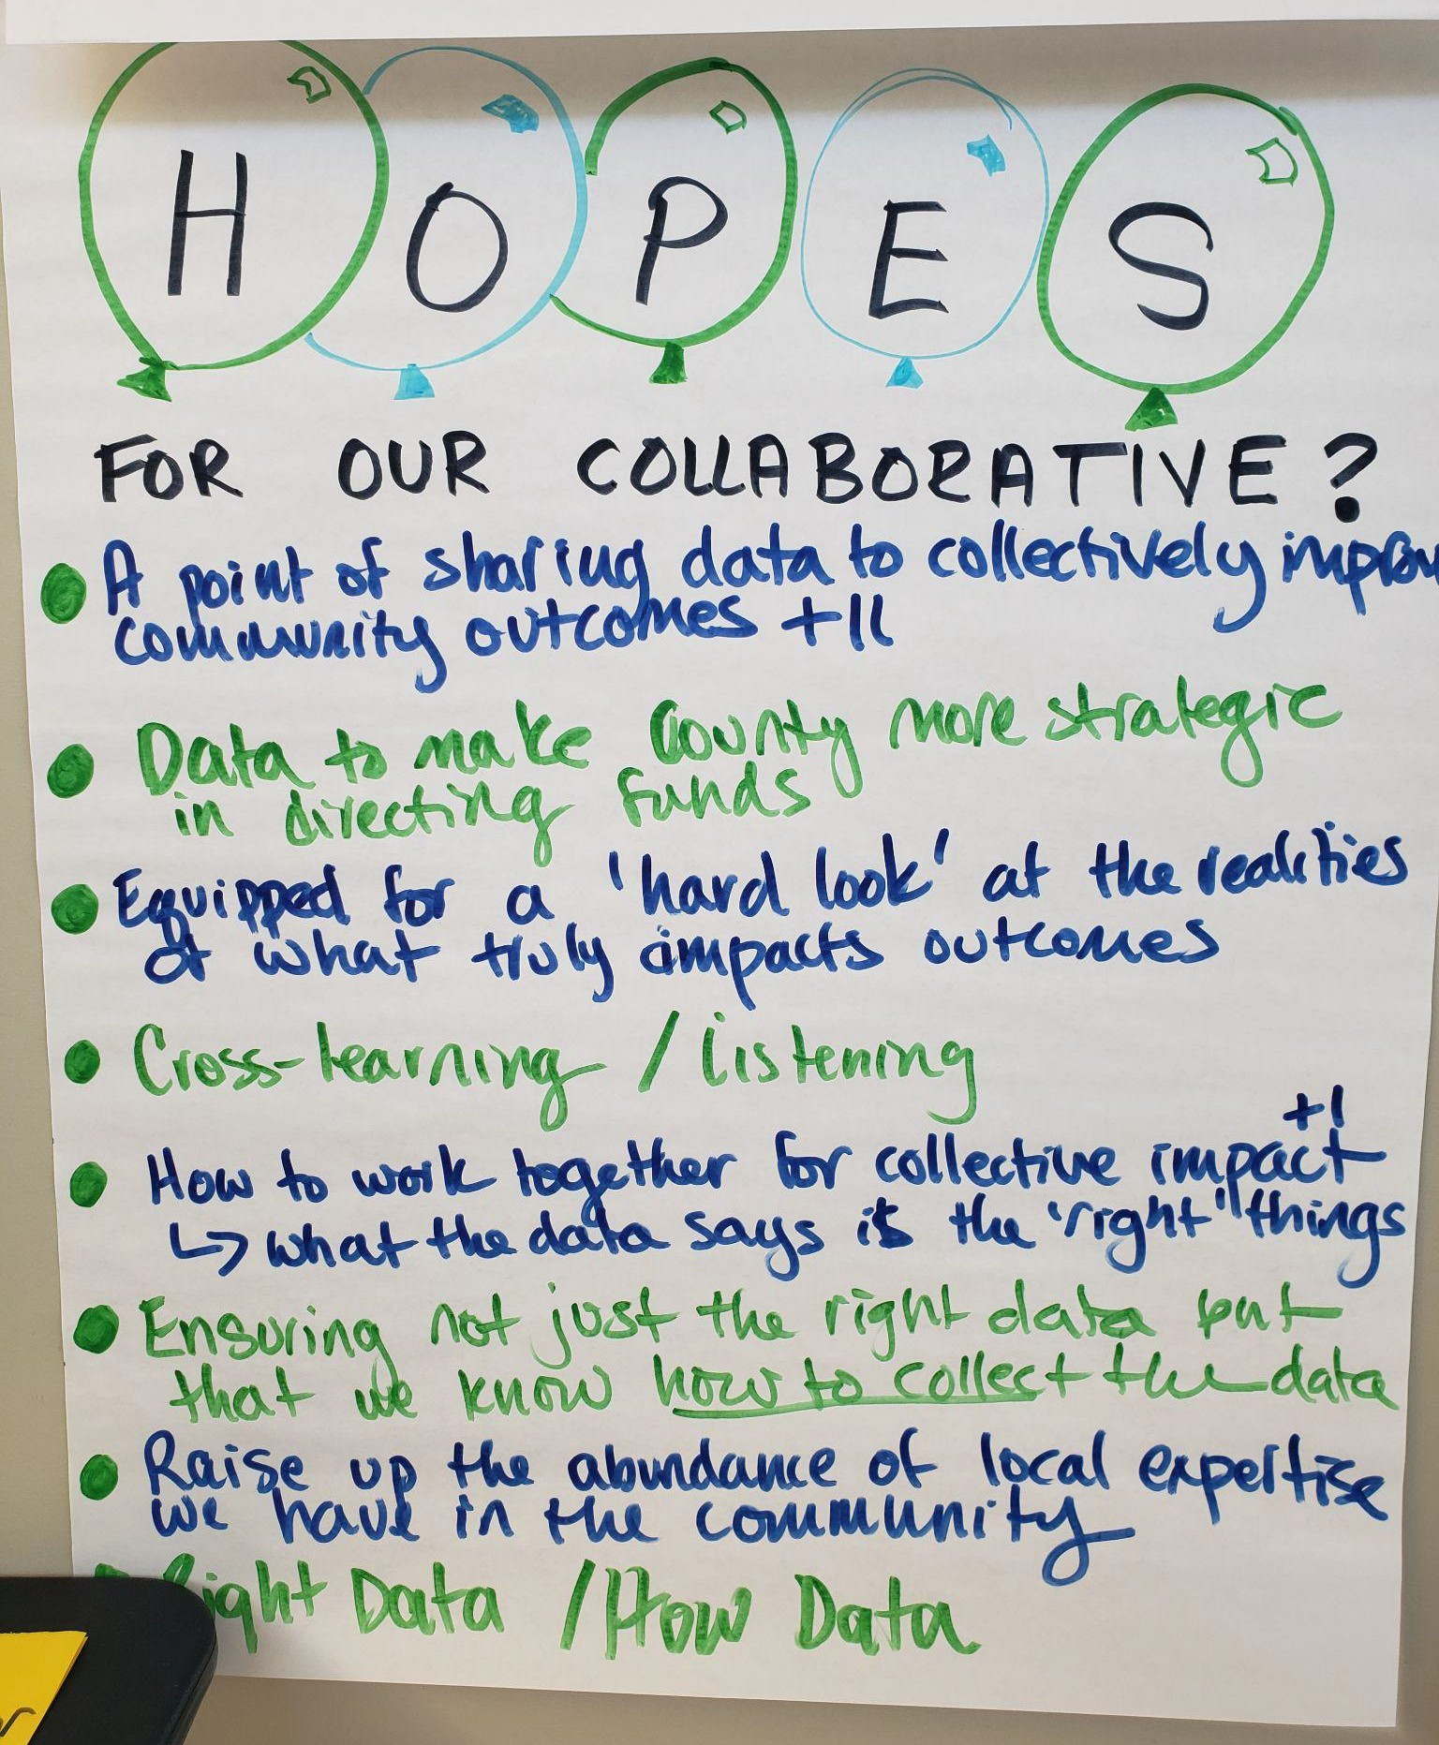
- A point of sharing data to collectively improve community outcomes +2
- Data to make County more strategic
- Equipped for a ‘hard look’ at the realities of what truly impacts outcomes
- Cross-learning / listening
- How to work together for collective impact +1 - what the data says is the ‘right’ things
- Ensuring not just the right data but the that we know how to collect the data
- Raise up the abundance of local expertise we have in the community
- Right Data / How Data

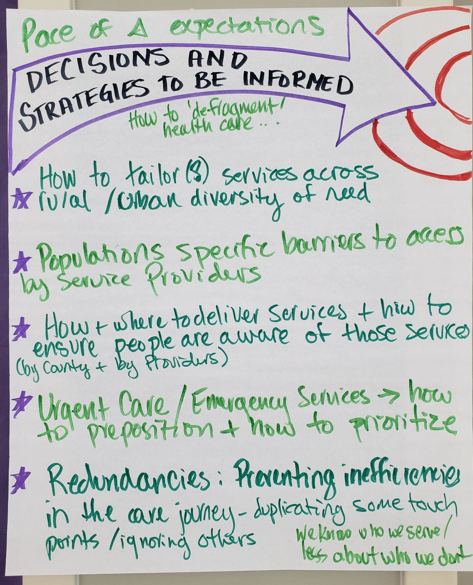
Decisions and Strategies to be Informed
This collaborative was convened for the purposes of sharing and ensuring the effective collection, analysis and application of quality Data. To have a meaningful conversation about what data to collect and how to be effective, the group grounded themselves first in the ‘why’ by talking about what decisions might be informed by that data. This helped ensure that the effort stayed demand driven and the conversation stayed anchored in what would be the most relevant and necessary data to focus on.

- How to deliver services most appropriately across rural / urban diversity of need
- Populations specific barriers to access by service providers
- How & where to deliver services & how to ensure people are aware of those services (by County & by providers)
- Urgent Care / Emergency Services - how to preposition & how to prioritize

- Redundancies: Preventing inefficiencies in the care journey - duplicating some touch points / ignoring others
- We know who we serve / less about who we don’t.
- Pace of change expectations

Overall Aim of the Collaborative
Participants discussed how expansive to make the focus of the collaborative. Whether the intent was to initiate the CAST process with the long term goal of creating recommendations about Services overall or to keep the focus on Behavioral Health. The determination was:

The aim of the collaborative is to ideally increase, and at a minimum, maintain, Behavioral Health Outcomes in the County. In the face of a likely constriction of resources, it is focussed on helping answer the question - what are the critical services that we need to prioritize to ensure Behavioral Health Needs are met.

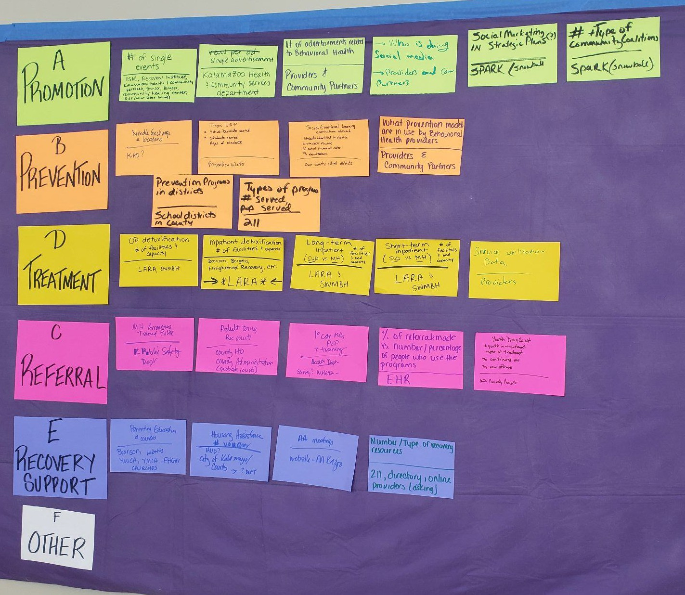
WHAT Data?
Review the CAST Framework, and particularly the calculator tool and the categories that it uses, the groups initially brainstormed within those categories essential data that would need to be collected in order to sufficiently feed the calculator and inform the analysis. An image of that brainstorm is here.

After that brainstorm the data was clustered by the likely source, or provider of the data. This allowed the group to identify who would be necessary partners in the process.

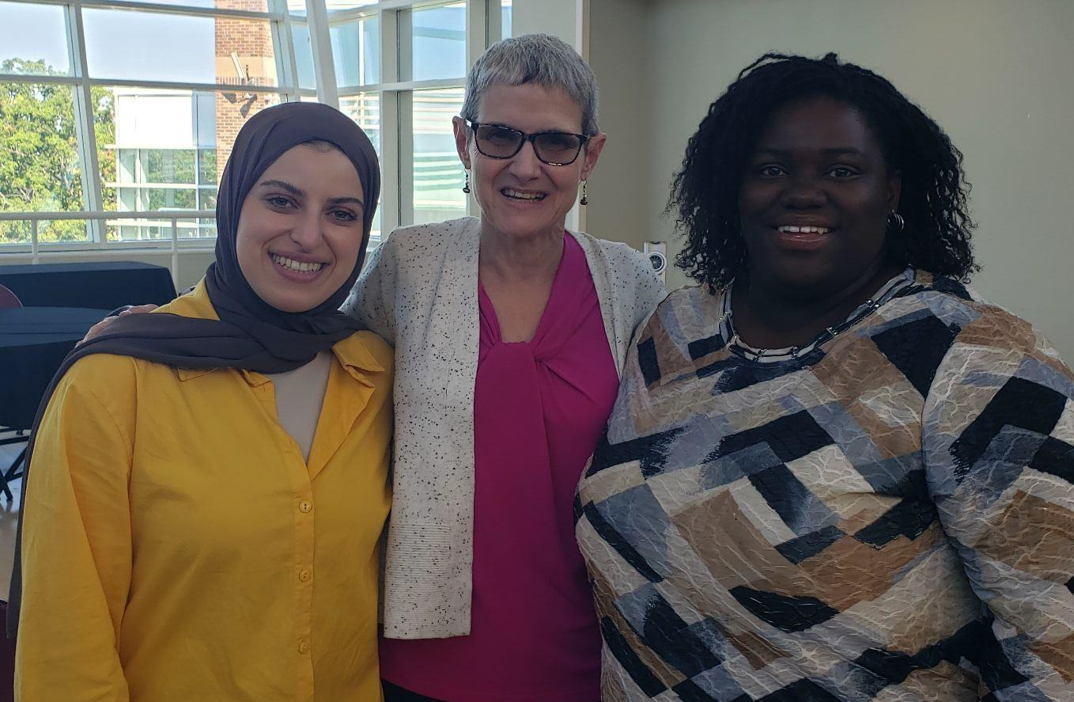
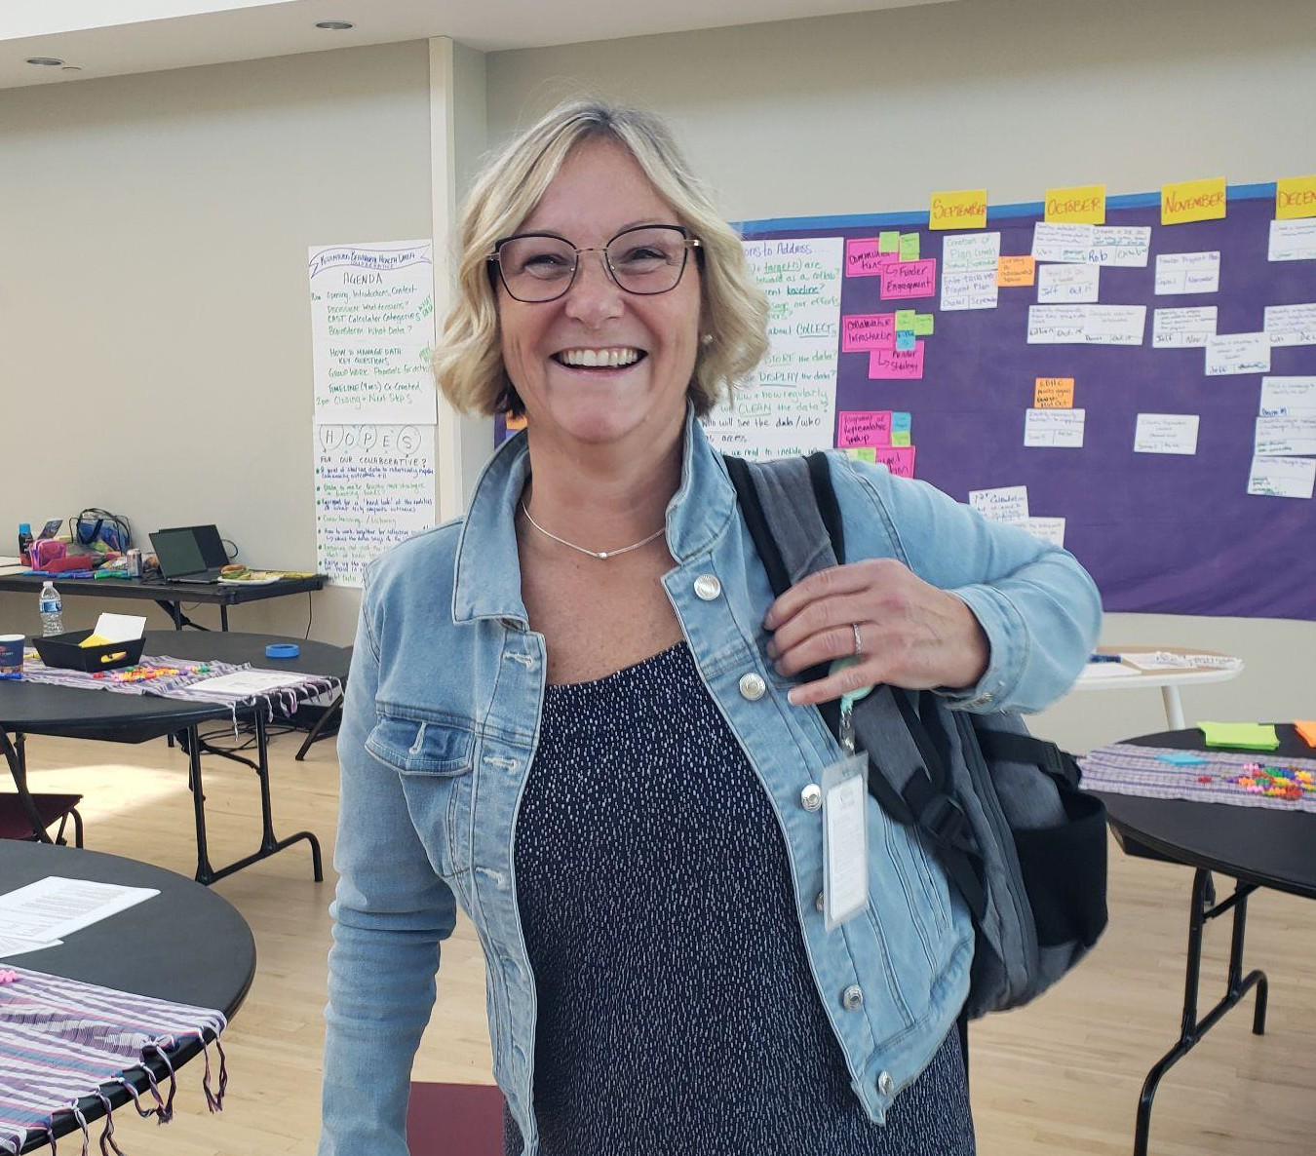

WHAT Data?
Participants identified where to locate different types of data and where to locate it for the local service data needed for CAST.

Community at large | SPARK | Licensing & Regulatory | KPAC | Providers & Stakeholders | Schools | Dept of PH
AA Meetings/ website AA Kalamazoo  # of Professional therapist, Doulas, CHWs (formal & Informal)/ Blueprint for Peace (Goal 2)  Parenting Education # courses/ Bronson, MDHHS, YWCA, YMCA, FHC,  Churches CHNAs | Prevention: # of single events / ISK, Recovery Institute, Kalamazoo Health & Community Services, Bronson, Borgess, Community Healing Center, RISE (other sober living)  Prevention: social marketing in strategic plans? / SPARK / snowball  Prevention: # & type of community coalitions / SPARK / snowball | Treatment:  Long-term inpatient (SUC vs MH) # of facilities & bed capacity / LARA / SWMBH  Treatment:  Short-term inpatient (SUD vs MH) # of facilities & bed capacity / LARA / SWMBH  Treatment: Inpatient detoxification # of facilities & capacity / Bronson / Borgess / Enlightened Recovery / LARA  Treatment: OP detoxification # of facilities & capacity / LARA / SWMBH  Referral: 1 degree Car MDs PCP with training / Health Dept  / Survey? / WMED | Adult Drug Rx courts/ KHD, KAdmin (probate courts)  MH Awareness Transit Police/ K Public Safety  Youth Drug Court, # in treatment, types of treatment, % continued use, % new offenses/ K County Courts | Types of EBP, # of school districts served, # of students served, ages/ Prevention Works  # of advertisements related to Behavioral Health/ Providers & Comm Partners  Telehealth & Mobile Tx/ Bronson, WMed  Free Clinics/ Insur Providers, EHRs  What Prevention models used by BH providers/ Providers and Comm Partners  Service Utilization Data/ Providers  Who is doing social media/ Providers & Comm Partners  # of referrals made vs # /% of people who use the programs/ EHR  Service Utilization/ Hospitals | Social Emotional Learning (curr utilized)  Students identified to receive, # of students, % suspension, % absenteeism/ County school districts  Prevention Programs  / districts | Needle Exchange # locations/ KHD / Opioid Coalition  Single Advertisement  / KHCHS department
United Way |  |  |  |  |  | 211
Recovery Support: United Way  Recovery Support: Housing Assistance # Voucher / HUD? City of Kalamazoo / County / Department? |  |  |  |  |  | #/ Type of recovery resources/ 211 directory, online providers (asking)  Types of programs # served, pop served/ 211

Key Questions to Address
- What goals and targets are we working towards as a collaborative?
- What’s our current baseline?
- How will we message oru efforts to possible partners?
- How will we go about collecting the data?
- How will we store the data?
- How will we display the data?
- When & how & how regularly will we clean the data?
- Who will see the data/ who has access?
- Who do we need to include in key conversations:
  - Choosing targets
  - Data analysis?
- Who will champion?
- How will we document the effort? (ie Blueprint for Peace)
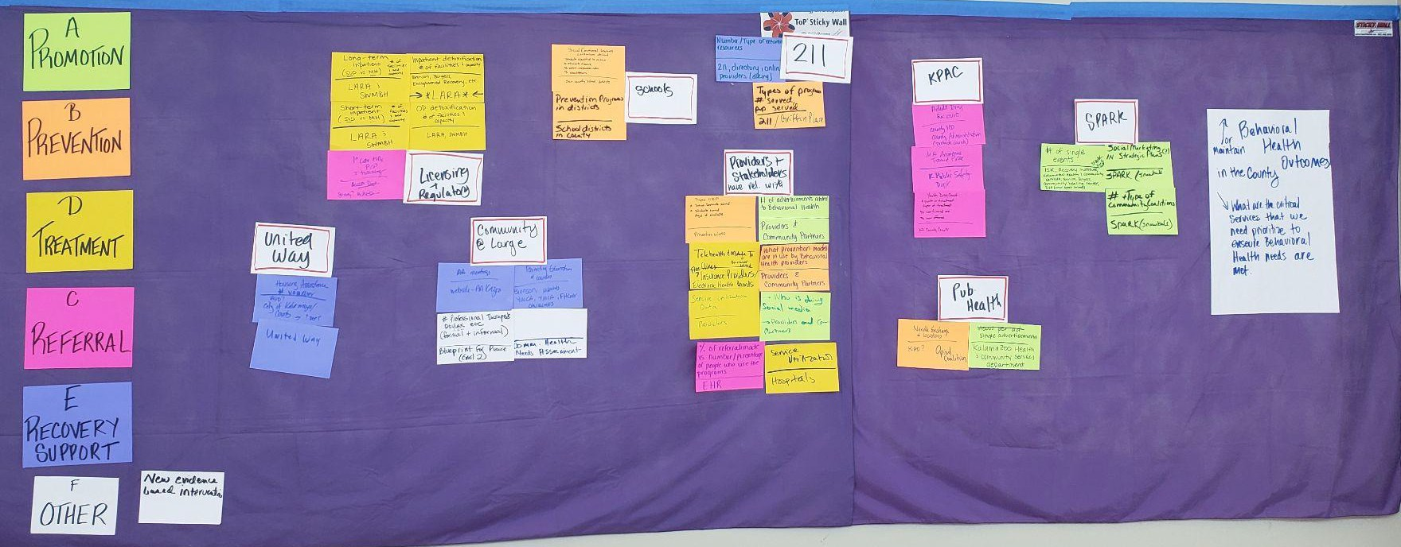

Getting Started

Kalamazoo Behavioral Health Data Collaborative: Timeline for Implementation
Working Area | Sep - Oct | Nov - Dec | Jan - Feb | March - May
Communications  (incl: Funder Engagement)  Leads: Dianne S., Crystal, Lilian | Creation of Plan (Levels)  Joshua Sept  Enter Tasks into Project Plan  Crystal Sept  Survey KBHDC re: preferred collaboration platforms (google, slack, etc) Crystal Sept  Design document / presentation for communication Lilia Oct  Create a PR Doc w/ why, who, how & CAST concept, need calculation Rob  Present PR Doc to funders Jeff  Oct 15th | Finalize Project Plan Crystal  November  Create a communication plan (include key talking points) Lilian December  Develop website configuration with real time data / reports for displaying / sharing Lilian December |  | Utilize project plan, meeting notes, and data reports to document effort Crystal May
KBHD  Collaborative Infrastructure  (incl: Funder Strategy) Leads: Lillian S, Dianne S., Jeff Patton | Identify champion(s) from Executive group & other roles Lillian Oct 15th  Designate roles for collaborative  Dianne Oct 15 | Identify a project officer(s) to make a final decisions & represent the project Jeff November 1  Develop a strategy to interact with funders Jeff November  Identify organization / person responsible for data collection, input & analysis | Training parties to facilitate groups around making hard decisions based on the data collected Lillian Jan 30th

 |  | (secure) Rob Dec. 1
Alignment with Representative Group  Leads: Diane M, Dianne S  Target Selection  Leads: Rob, Chris, Diane S. | KBHDC meets again Mid October  Identify community partners to engage / convene Diane M. End of Oct | Identify ‘representative’ leaders (represent voices) Dianne S. Beginning November  Hold a convening to identify our goal Diane M Dec  Identify major concerns & challenges using current data Comm. Doc. / Data Committee  Identify target / goal Community Group consensus / funders | Develop data sharing agreements (draft) Lilia January  Build a community wide coalition w/ stakeholders - maintaining engagement to target update on progress Jeff Beginning February | Reconvene coalition to show our work Diane May
Data Collection Mechanics  Leads: Sheila, Chris, and Blaire | First calculation - What we need to have in place Blaire Oct 1st  Develop talking points in order to receive data Lilia / Rob Oct |  | Identify data and sources Blaire Feb  Identify parameters of data being collected Blaire Feb  Develop a codebook for data collection Blaire Feb | Create the infrastructure for data collection Blaire March  Collect aggregate /  de-identifiable data Blaire  May  Review local data (ie CHNA, County Health Rankings, Kids Court) Blaire May  Identify proxy outliers in the data (ie other ‘trickle down’ results) Blaire TBD

