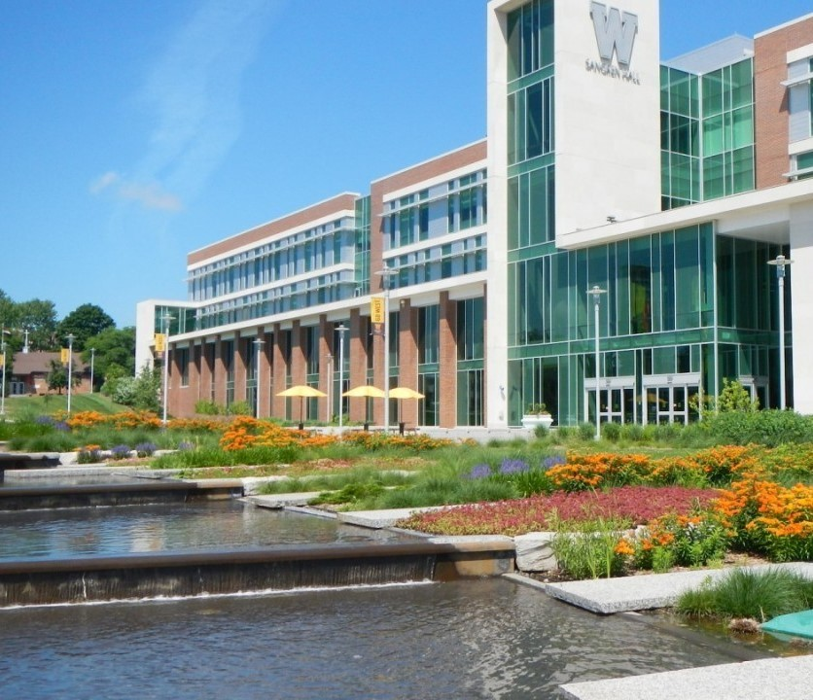

Office of Institutional Research

Strategic Plan

2018-2022



Executive Summary
The Office of Institutional Research (IR) engaged in strategic planning activities from August through October 2018 in conjunction with administrative program review. Weekly meetings were held- during which time the staff established the IR mission, vision, and values; critically examined stakeholder needs, internal resources, current functions, and priorities; conducted a SWOT analysis; and outlined strategic goals. The Office completed this effort in January 2019.

The vision, mission, and values in this plan provide a pathway toward strengthening and focusing the role of institutional research at Western Michigan University (WMU), and emphasizes a commitment to providing information, analysis, and necessary research in a timely, ethical, and efficient manner. The plan includes four strategic goals supported by twelve objectives and twelve measures of success to ensure those goals are reached. Our goals and objectives are summarized as follows:

First, the Office of Institutional Research is the best source of accurate and timely information for the University and a valuable source of technical expertise. In order to highlight our role at WMU we will actively promote awareness of IR through direct communications; arrange technical workshops, training sessions, and open office hours; and improve functionality and accessibility of the IR website.

Second, the Office of Institutional Research leads an expansive and effective data governance effort. To build upon this role, IR will lead the strengthening of policies and procedures regarding the data governance structure for data classification, security, and retention of data; increase integration of data sources; and leverage our role as head of data governance to encourage mutually beneficial processes.

Third, the Office of Institutional Research offers a portfolio of advanced analytics to the University community to help campus leaders make informed, data-driven decisions. To enhance the quality of information we provide, IR will develop more strategic reporting initiatives in the form of dashboards, scorecards, and operational indicators for offices, departments, and senior leadership; research and produce advanced analytics more frequently to improve the effectiveness of current activities and plan for the future; prepare content that allows for more on-the-fly user customization; and prioritize strategic insights and high impact projects.

Lastly, through this process we have identified the steps required to enhance the Office’s preparedness for the potential loss of institutional knowledge through attrition and turnover. To lessen the impact of such events, IR will develop a repository of institutional knowledge, processes, and definitions; create succession plans, and initiate knowledge sharing sessions; and establish naming and coding conventions to systematize metadata management.

Mission
The Office of Institutional Research serves the University community by providing the data, analysis, and research needed to make informed, data-driven decisions in a timely manner. The Office leads data governance at Western Michigan University by deliberately managing, ensuring, and promoting the integrity of data in order to foster a culture that values using information to improve the effectiveness of current activities and plan for the future. We anticipate the needs of the University community and align our services to directly support the University’s mission of being learner centered, discovery driven, and globally engaged. We serve as the leader in responsible use and management of information and help others achieve maximum value from data as an asset.

Vision
The Office of Institutional Research consistently achieves excellence in meeting the evolving information needs of the University community and is the most reliable source of timely, high-quality analysis for compliance, institutional planning, and decision support.

Values
The Office of Institutional Research serves the University community and its stakeholders according to these core values:
- We act with honesty and integrity
- We use and manage information responsibly and make every effort to prevent its misunderstanding and misuse
- We maintain objectivity by minimizing subjective biases in our work
- We secure confidential information to uphold the trust of our stakeholders
- We show pride, enthusiasm, and a dedication to high quality in all that we do

Current State
Since 1970 the Office of Institutional Research has served the needs of WMU faculty, staff, and students in compiling, analyzing, and distributing data concerning the function of the University. It also continues to provide information to comply with mandated state and federal reporting requirements. In the intervening years, the name, purpose, and scope of IR have changed in an effort to better reflect the services provided by the Office:
1970-1983: Office of Institutional Research
1983-1994: Institutional Research Office
1994-1998: Office of Planning and Institutional Research
1998-2004: Academic Planning and Institutional Data
2004-2009: Student Academic and Institutional Research
2009-present: Office of Institutional Research
The expanded role of IR at WMU includes providing knowledge and information to support administrative planning, policy and decision making, business intelligence, and institutional effectiveness.

ORGANIZATIONAL CHART

PERFORMANCE METRICS
The Office of Institutional Research evaluates the effectiveness and efficiency of its operations using the following metrics:
- Mandated reports are completed accurately and on schedule
- Census data is audited, cleaned, and released in a timely manner
- Requests from stakeholders are completed in an opportune time

CURRENT FUNCTIONS AND SERVICES
- Strategic and operational reporting
- Data governance/stewardship
- Enrollment forecasting
- Compliance reporting (federal & state)
- Responding to surveys/guidebooks/rankings
- Data analytics
- Institutional planning
- Faculty activity reporting
- Accreditation support
- Supporting ad hoc data needs

SWOT ANALYSIS
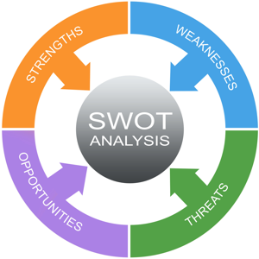
SWOT is a framework designed to help teams identify key aspects of their work and determine how to leverage this information to enhance the unit’s planning and decision-making processes. The following strengths, weaknesses, opportunities, and threats were identified during the strategic planning process:
- Strengths:
  - Staff expertise and dedication
Haughey, D. (n.d.). SWOT Analysis. Retrieved from https://www.projectsmart.co.uk/swot-analysis.php
  - Prioritizes data integrity and accuracy
  - Boosting efficiency through data self-help tools
- Weaknesses:
  - Thorough data process documentation
  - Insufficient personnel to expand the Office’s role
  - Succession planning and knowledge transfer
- Opportunities:
  - Playing a stronger role in data management and data governance
  - Creating and meeting increased demand for data, accountability, and reporting
  - Moving toward a more robust self-service environment with a greater diversity of offerings
- Threats:
  - Budget cuts
  - The creation and/or strengthening of data silos
  - Being unprepared for the move from locally managed information systems to cloud-based systems

Goal 1
The Office of Institutional Research is viewed as the primary source of accurate and timely information for the University.

OBJECTIVES
- Actively promote awareness of IR and our technical expertise through direct communications
- Arrange technical workshops, training sessions, and open office hours
- Improve the functionality and user-friendliness of the IR website

MEASURES OF SUCCESS
- Increased number of outreach efforts
- Begin and continue training sessions and open hours
- Decreased frequency of data requests for data available on the Office’s website

Goal 2
The Office of Institutional Research leads an expansive and effective data governance structure.

OBJECTIVES
- Lead the strengthening of policies and procedures regarding the data governance structure for data classification, security, and retention of data
- Increase integration of data sources
- Leverage our role as head of data governance to encourage mutually beneficial processes

MEASURES OF SUCCESS
- Elicit support from upper level leadership and lead regular meetings with core users
- Increased data integration
- Frequency of meetings with data owners across campus

Goal 3
The Office of Institutional Research offers a portfolio of advanced analytics to the University community.

OBJECTIVES
- Develop more strategic reporting initiatives
- Plan and complete more advanced analytic projects
- Prepare content that allows for more on-the-fly user customization

MEASURES OF SUCCESS
- Increased cooperation with departments to create dashboards and scorecards
- Number of advanced analytic projects completed each year
- Self-service business intelligence portals integrated

Goal 4
The Office of Institutional Research maintains a comprehensive and enhanced quality control program for data and information.

OBJECTIVES
- Continue to institute and enforce quality control procedures over new and existing data systems
- Develop policies and procedures to store and transfer institutional knowledge of our processes and definitions
- Establish naming and coding conventions to systematize metadata management

MEASURES OF SUCCESS
- Census data is audited, cleaned, and released in a timely manner
- Creation of succession plans and implementation of a documentation repository
- Established naming and coding conventions to systematize metadata management

