

Policy Name: Transfer Credit

ARC-PA Standard: A3.12

Policy Statement:

Course work in the Physician Assistant professional curriculum is very different from most traditional graduate level work. Each semester’s course work builds on the prior semester’s work; therefore, it is imperative that all students at the Western Michigan University Physician Assistant Program complete the required course work in the prescribed sequence. No transfer of credit from any other institution will be allowed to fulfill any one of the Western Michigan University Physician Assistant Program Medical Science course work or clinical requirements.

Date Reviewed: 5/01/2025
To Be Reviewed: 5/01/2026

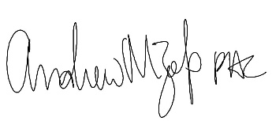
______________________
Program Director

