

Policy Name: Student Work Policy

ARC-PA Standard: A3.02, A3.03

Policy Statement:

While the Physician Assistant Program does not encourage students to work during the didactic and clinical years, the program does not prevent students from obtaining outside employment. The program will not employ any physician assistant student as a graduate study assistantship. The student who chooses to obtain outside employment must realize that the program will not make any EXCEPTIONS or accommodations regarding course work or clinical assignment due to their employment.

During the didactic or clinical year, PA students in the program must not be required to:
- Work for the program
- Substitute for or function as:
- instructional faculty and
- clinical or administrative staff

All clinical sites will be notified of this policy upon acceptance of students for clinical rotation at the facility. Any violations of this policy, as determined by the Clinical Rotations Coordinator or Director of Clinical Education, will result in removal of the student from that clinical site and reevaluation of the clinical site by the PA Program.

Date Reviewed: 5/1/2025
To Be Reviewed: 5/1/2026

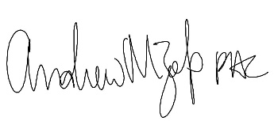
______________________
Program Director

