

Policy Name: Medical Terminology Test

Policy Statement:

The language of medicine is very important in the completion of the students’ training. The medical terminology self-instruction work is the first step in the learning of this new language. This self-instructional work is to be completed prior to the start of the fall semester of the first year of training. The student will have to score an 80% or better to pass the test.

Should a student not achieve a score of at least 80% or better, the student will be given an opportunity to retest to achieve 80% to pass. Failure to achieve 80% on the retest will require the student to register for MDSC 2010 Medical Terminology. If the student fails MDSC 2010 the academic review process will be started as outlined in Semester and Academic Review Policy. The outcome of this process could be dismissal from the Program.

Date Reviewed: 5/01/2025
To Be Reviewed: 5/01/2026

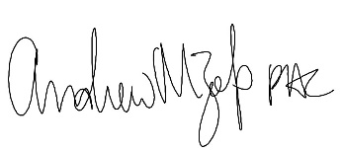
______________________
Program Director

