

Policy Name: Course Credit by Examination

ARC-PA Standard: A3.12

Policy Statement:

Course work in the Physician Assistant professional curriculum is very different from most traditional graduate level work. Due to the course work each semester building on the prior semester’s work, it is imperative that all students at the Western Michigan University Physician Assistant Program complete the required course work in the prescribed sequence.

No course credit by examination for any Medical Science course in the Physician Assistant Program curriculum will be offered.

Date Reviewed: 5/01/2025
To Be Reviewed: 5/01/2026

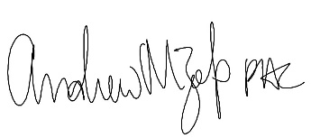
______________________
Program Director

