

Policy Name: Advanced Placement

ARC-PA Standard: A3.12c, A3.15

Policy Statement:

Course work in the Physician Assistant professional curriculum is very different from most traditional graduate level work. Due to the course work each semester building on the prior semester’s work, it is imperative that all students at the Western Michigan University Physician Assistant Program complete the required course work in the prescribed sequence.

No advanced placement within the Physician Assistant Program will be allowed for prior academic or clinical experience.

Date Reviewed: 5/01/2025
To Be Reviewed: 5/01/2026

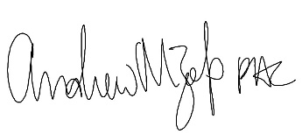
______________________
Program Director

